Vladyslav danyliuk Bellerbys College 2513818

Commodity Description

I want to describe commodity of wheat. So basically wheat is a grass widely popular for its seed, a cereal grains which is a worldwide necessary food. Cultivation of these grains led to the creation of domestic strains. Wheat was generally chosen by simple farmers. Archeological research shows that it was first cultivated in the southern Levant , with finds dating back as far as 9600 BCE. Some genetic scientists suggest that einkorn wheat was firstly grown in southeastern Turkey.

Basically, the biggest producer of wheat in the world is China. Judging by statistics , wheat production in China was 133,590 thousand tones that is 21.91% of the world's wheat production.
Graph 1:
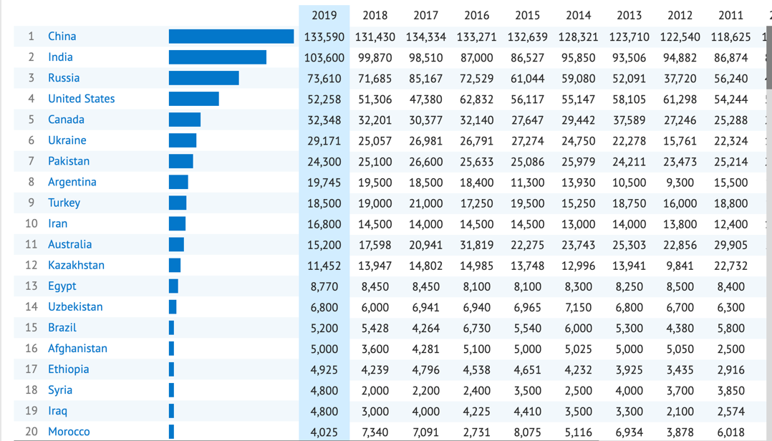

Source:https://knoema.com/atlas/topics/Agriculture/Crops-Production-Quantity-tonnes/Wheat-production(2019)

There is quite long and hard process of making wheat to be ready and to be sold. Firstly,farmers planting seeds, looking for disease and checking plant health
until collecting. Combines picking the wheat seeds , which are then loaded into a truck.Secondly, collected grain is traded to a local grain silo. The grain storage can keep the seeds for a long time, or it can sell it immediately. After that, local storages sell their grain to terminal elevators, which separate, clean and keep the market price of the wheat. The wheat is then sold to flour millers for internal use, or it is loaded into transport (planes ,ships ,cars etc.) shipped for international markets and the flour mills pulverise the wheat into several types of flour. The factories can also use the wheat to make ready made products. Basically, the wheat and flour products are delivered to markets and other food traders . Finally, bakers can make some delicious from wheat so you can buy them in shops or markets and eat them. You can make a lot of dishes from the wheat such as bread, cakes, cupcakes etc. Also, in CIS, companies make vodka based on wheat. Products, that are made from such seeds contains carbohydrates, so we can’t basically live without them.

Commodity Prices

Source: https://www.indexmundi.com/commodities/?commodity=wheat&months=180
(2020)
Graph 2:
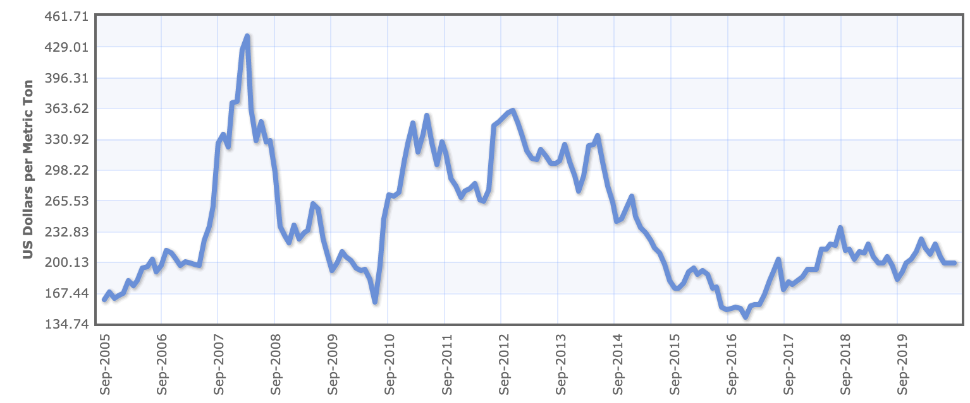

The above chart shows that price changes of wheat in 2005 the price was $167.44 per metric ton. The price remained steady until 2007 reaching $200.13 per metric ton. After that, there was a dramatically rise in the price of wheat reaching it’s peak more than $429.01 in the middle of 2007 because of global financial crisis. At the end of this crisis, there was sharply fall until 2010 reaching less than $167.44 per metric ton. Prices were unstable after the crisis so the price increased up to $363.62 in late 2010. After that, the price of wheat was fluctuating during next few years reaching $330.92 in late 2013. There were a lot of climate disasters such as tsunami in Japan, flood in China, tornadoes in the USA. However, there was a dramatically fall up to the lowest point of the graph- near $134.74 in 2016. Finally, there was a slightly rise up to nowadays when price remains steady and reaching $200.13 per metric tone. This tells us that the price of wheat has been very volatile over the last 15 years. Such changes in the price of commodity were caused by climate changes and financial crisis. Also, there were some trade wars between the USA and China or Russia, so such wars had huge impact on the price of wheat. Nowadays, there is a huge disaster- Covid-19. This decrease is very dangerous for world’s economic and has big impact on the price of agriculture commodities.

Reasons for and effects of price changes

In 2006 here was a large increase in the price of wheat caused by world food price crisis and huge inflation.

Graph 3 shows that the supply curve shifts to the left. It means that the price of commodity decreases because of flood or other climate changes and if supply curve shifts to the left and it is greater than that of the demand curve, the equilibrium price will increase.
Graph 3
Source:https://www.schroders.com/en/us/private-investor/insights/economic-views/climate-change-and-the-global-economy-growth-and-inflation(2015)
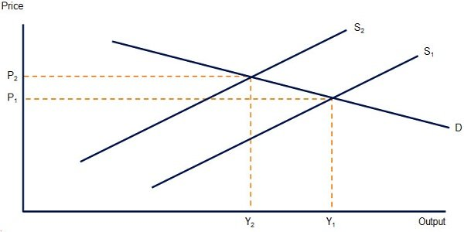

In the UK, prices started to increase, however, salaries remained on the same level. That’s why people couldn’t buy as much as they bought before the crisis. Moreover, companies changed price for product made using the wheat. That means that bread, flour, became more expensive. Government provided new credit terms and tried to raise the salaries.

In the 2008 there was large change in the price of wheat due to ending of the financial crisis and increasing production of commodity.
The supply curve will shift to the right. By the way, it shows the law of supply-as the price of a given commodity increases, the quantity supplied increases too. Also, the increasing in supply will cause the equilibrium price to fall.

Graph 4:

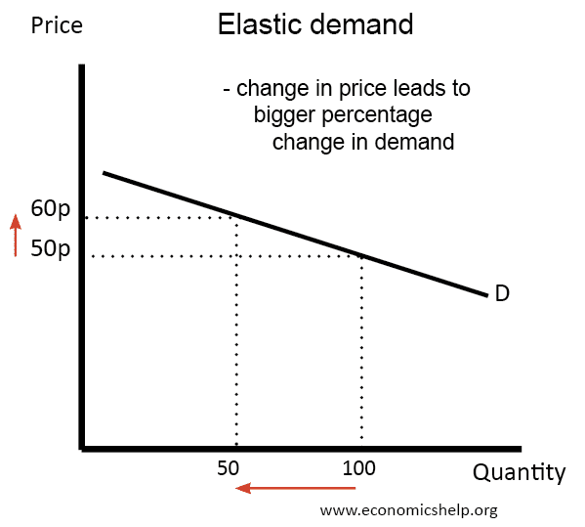

Source: https://www.economicshelp.org/microessays/equilibrium/price-elasticity-demand/(2019)

Countries started to produce more wheat and sell it. At the same time government provided higher salaries so people could but this commodity. Workers had more motivation to work and they tried to work harder to earn more money. Companies had more profit from selling the wheat so they decrease price for products made using the commodities and they didn’t use other alternative products. After the financial crisis the demand decreased so supply increased because people have enough money the wheat and companies have enough resources to produce it. Graph 4 shows the elasticity of demand.

Government interventions

Firstly, government needs to provide new technologies in farming such as a new equipment, chemical additives and new types of crops. Basically, they cause huge increase of harvest. Manufacturing facilities around the world have significantly expanded. Also, new technologies cause reducing the price of wheat, so the supply curve shifts to the right. That’s why government provides farming programs aimed at keeping prices from falling, especially during Covid-19 pandemic.
Graph 5:
https://www.ifpri.org/blog/covid-19-related-trade-restrictions-rice-and-wheat-could-drive-prices-and-increase-hunger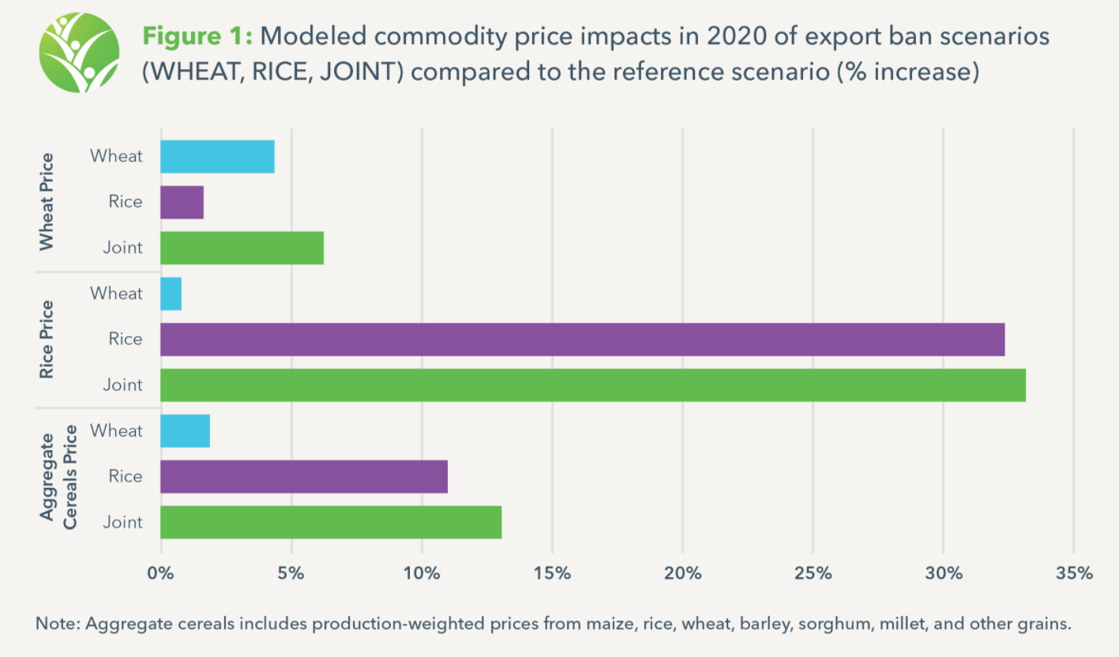
Secondly, the UK government opened markets for higher competition between companies. They are trying to provide better prices for customers to make more profit. So prices will become lower. Government tried to participate more companies into the wheat market during the global financial crisis in 2008. After this intervention, the prices dramatically decreased. Companies made more wheat and put lower prices, because they competed with each other and tried to provide better terms than other companies. Also, government tries to control monopoly of wheat producing, because investors don’t want to make long term investments, because they won’t make enough profit.

Source:https://finance.yahoo.com/quote/ZW=F?p=ZW=F&.tsrc=fin-srch(2020)
Graph 6:
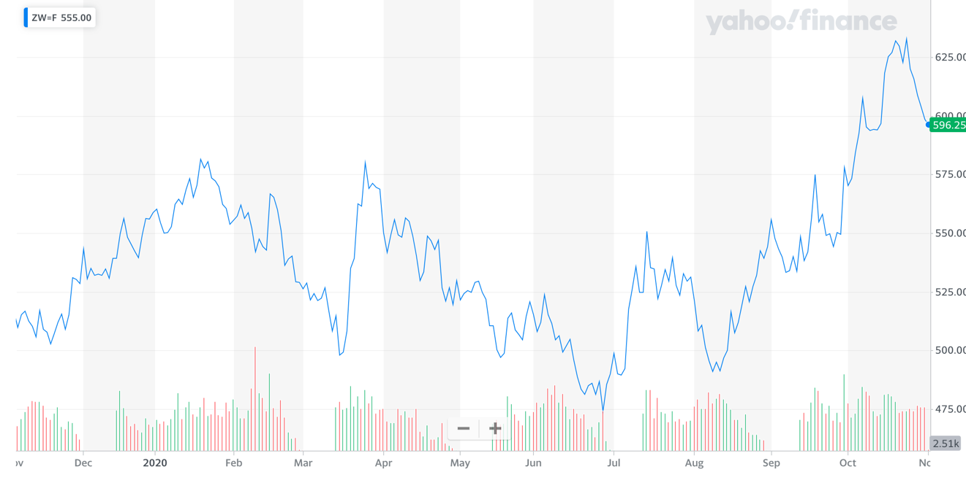

For example, the USA government provided trade policy that can decrease the price of getting wheat from farmers to their clients around the world. Basically, they opened information on trade parley. This decision has really improved market access. Also, the government started to monitor the current trade agreements to secure rules that are operated properly. After that, a lot of companies started to work honestly and adhere to contracts. Finally, the government supported the effective use of wheat in international food programs that are supported by USA. These interventions really helped the US economic after the global crisis in 2008. Nowadays, the price of wheat are lower than in 2008, but Covid-19 is a big challenge for all countries and they need to provide more effective interventions . However, there are some problems of this trade policy. Firstly, the government needs time to provide this policy and make it effective. Secondly, they need to spend a lot of money on it, and develop this policy in long term.

Source:https://www.macrotrends.net/2534/wheat-prices-historical-chart-data(2020)
Graph 7:
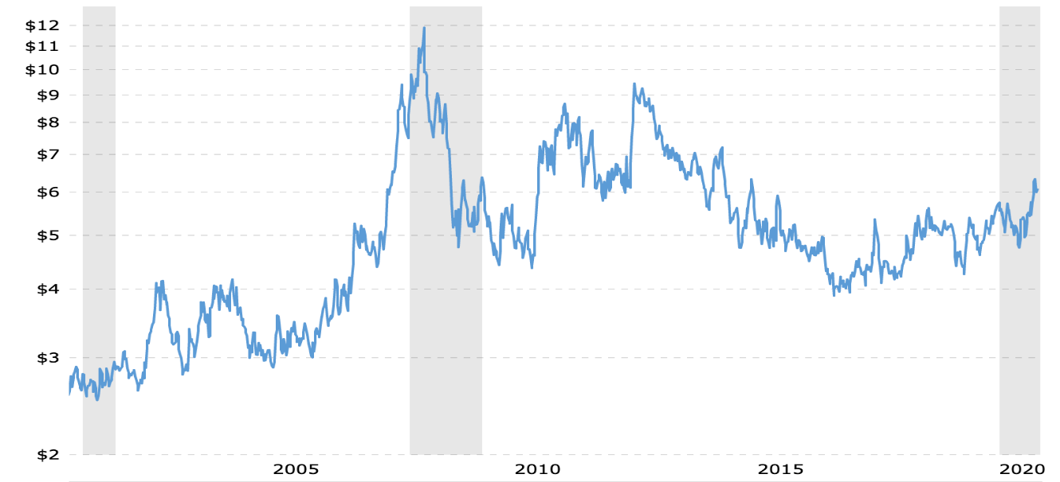

Evaluation

Nowadays, it is very hard to predict changing in the price of wheat. Basically, wheat trade is one of the most major commodities trade in the world. It is strong commodity which has low possibility to get off. Although the trend is move up, there are still some causes that could have impact on the plateau of the wheat production in the future. For example, climate change can impact commodity production.
It can be flood or huge storm and it can really reduce wheat production. Also, we shouldn’t forget about COVID-19 pandemic and it can really influence on wheat price. With the increase of tea production and export, government intervention policies sometimes lead to some consequences. Government is going to help huge companies to produce more because they have lost a lot of money during the lockdown period.
In evaluation, wheat is suffering from rising costs and stagnant prices, which has given rise to increase in price and reduce the number of buyers. Also, a lot of analysts predict that the price of wheat will fall in next two years.
In conclusion, the wheat market isn’t stable nowadays and ,as I said, it is very hard to predict the price of commodity. Also, there won’t be any alternatives to wheat and price will be unpredictable. Judging by prediction, the price will fall in short term. I think that price will fluctuate in long term and will rise on current level.
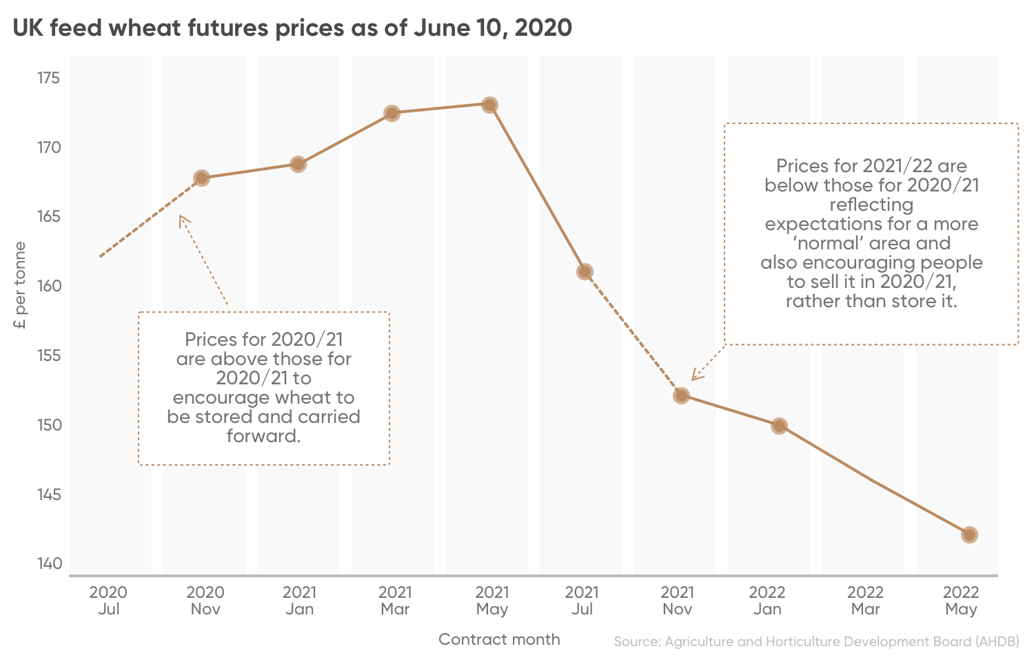
Source :https://capital.com/wheat-price-forecast(2020) Graph 8:

Conclusion

In conclusion, price will be fluctuating in short term because of climate changes, Covid-19, government interventions etc. However, in long term price can dramatically increase or decrease because of wars, financial crisis or new alternatives to the wheat.

Bibliography

Graph 1: KNOEMA, Jul 2020, https://knoema.com/atlas/topics/Agriculture/Crops-Production-Quantity-tonnes/Wheat-production#:~:text=China%20is%20the%20top%20country,account%20for%2064.85%25%20of%20

Graph 2: USDA Market News, June 26, 2020, https://www.indexmundi.com/commodities/?commodity=wheat&months=180

Graph 3: Keith Wade and Marcus Jennings, Jul 2015, https://www.schroders.com/en/us/private-investor/insights/economic-views/climate-change-and-the-global-economy-growth-and-inflation

Graph 4: Tejvan Pettinger, Nov 2019, https://www.economicshelp.org/microessays/equilibrium/price-elasticity-demand

Graph5: Timothy Sulser and Shahnila Dunston,May 2020,

https://www.ifpri.org/blog/covid-19-related-trade-restrictions-rice-and-wheat-could-drive-prices-and-increase-hunger

Graph 6: Yahoo finance,2020
https://finance.yahoo.com/quote/ZW=F?p=ZW=F&.tsrc=fin-srch

Graph 7: Macrotrends, Nov 2020, https://www.macrotrends.net/2534/wheat-prices-historical-chart-data

Graph 8: AHDB, June 2020, https://capital.com/wheat-price-forecast

