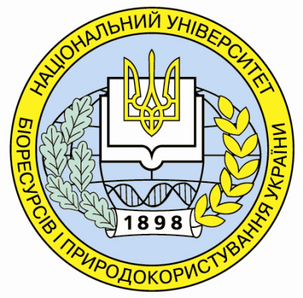

National University of Life and Environmental Sciences of Ukraine
Wrocław University of Environmental and Life Sciences, Poland

International scientific-methodological seminar
“Distance education – experience and perspectives”

May, 21-22, 2013
Kyiv

Program
21.05.2013
Building №3, room 68

Session scientific and methodological committee of the Ministry of Agrarian Policy and Food of Ukraine on introduction information systems and technology in university activities

9-30 – 10-00 | Registration
- – 11-30 | - Providing students of agrarian university e-learning courses based on the platform Moodle  - Experience NUBiP Ukraine (Dr.Olena Glazunova),  - Experience Wrocław University of Environmental and Life Sciences (Dr. Johanna Markovska),  - Speeches agricultural universities of Ukraine (committee members).  - Presentation of the "Regulations on ENK" and its discussion.
11-30 – 11-45 | Coffee break
11-45 - 13-30 | - -Presentation of training course on the programming technologies (72 hrs.) for teacher in programming. (Prof. Andriy Shelestov ).  - Presentation of the typical curriculum in informatics for of agrarian specialties and its discussion. (Dr.Olena Kuzminska)  - Discussion (committee members)
13-30 – 14-30 | Lunch
14-30 – 15-30 | - Problems and prospects of introduction single state electronic database records in higher education institutions (representative of the Ministry of Education)  - Providing of agrarian university licensed software (Dr.Oleksiy Tkachenko, Microsoft representative)  - Misc.
15-30 – 15-45 | Coffee break
15-45 – 17-00 | Discussion
18-00 | Dinner

Program

22.05.2013

Building №3, room 68

9-30 – 10-00 | Registration
10-00 – 10-30 | Seminar’s opening  - Prof. Natalia Ridey, vise-rector for academic, cultural and educational work, NUBiP of Ukraine;  - Dr hab. Oleksij Tkachenko, director of the ESI of Information and Telecommunication support of agricultural and environmental sectors of Economics, NUBiP of Ukraine;  - Dr hab. Maria Kulayets, director of the ESI of postgraduate education, NUBiP of Ukraine.
- – 11-30 | - Olena Glazunova, PhD in Pedagogics, associate professor, Dean of the Faculty of Computer Science and Economic Cybernetics of the NUBiP of Ukraine «Information and educational environment of the NUBiP of Ukraine for distance learning»  - Johanna Markovska, Doctor of Engineering, director of the Distance Education Center of the Wroclaw University of Life and Environmental Sciences «Distance Education in the Wroclaw Agricultural University»  - Maksym Mokriyev, P.h.D. in Economics, Associate Professor of Information Systems «The experience of implementing Moodle platform in NUBiP of Ukraine»  - Jacek Markowski, Doctor of Engineering, deputy of the director of the Distance Education Center of the Wroclaw University of Life and Environmental Sciences «Group work using the Moodle platform and available Internet resources»
11-30 – 11-45 | Coffee break
11-45 - 13-30 | - Olena Kuzminska, PhD in Pedagogics, associate professor of information and distance technology department «Creating a community of practice based wiki portal»  - Anna Daniel, master, collaborator of the Distance Education Center of the Wroclaw University of Life and Environmental Sciences «Experience of distance learning on design patterns and presenting learning course»
- Anton Zablockyi, chief engineer of the Distance Education Center «Theory and practice of using the built-in modules on the Moodle platform»
- Viktor Teplyuk, assistant of the vice-rector in Informatization «Experience of online distance education organization in the NUBiP of Ukraine»
- Vadym Ostapenko, head of the television center of the NUBiP of Ukraine «Method of usage video services and Web 2.0 services»
- Johanna Markovska, Doctor of Engineering, director of the Distance Education Center of the Wroclaw Agricultural University «Model of the student participation in the virtual training course»

13-30 – 14-30 | Lunch
14-30 – 15-30 | - Sergiy Bilan, chief engineer of the Distance Education Center «Legislature of the distance education in Ukraine»  - Taisiya Sayapina, assistant of information and distance technology department «The use of multimedia resources in the electronic course on the Moodle platform»  - Tetyana Biloochko, assistant of information and distance technology department «Standardizing the use of e-learning courses in the learning process of the NUBiP of Ukraine»  - Oleksandr Popov, head of information and distance technology department «Features of e-learning courses for supporting information sciences»  - Viktor Andryushchenko, assistant of the information systems department «Method of the testing system organization in electronic courses based on the Moodle platform»  - Olga Kasatkina, senior teacher of the Information systems department «Creating course page templates in the Moodle system»
15-30 – 15-45 | Coffee break
15-45 – 17-00 | Discussion
18-00 | Dinner

