A. Shvidenko

Dr. Agric. Sci., Prof., Academician of International Informatization Academy, leading researcher of Sukachov Institute of Forest of the Siberian Branch of the RAS and International Institute for Applied Systems Analysis (IIASA), head and responsible executor of many international projects (Siberia-II, IRIS, Enviro-RISK, Third Millennium Ecosystem Assessment).
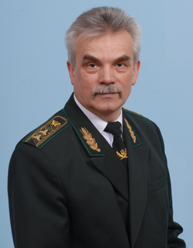 | P. Lakyda  Dr. of Agric. Sci., Prof., Director of Education and Research Institute of Forestry and Landscape-Park Management, Corresponding Member of NAAS of Ukraine, Academician of International Informatization Academy, Academician of Forestry Academy of Sciences of Ukraine, Excellent Educator of Ukraine, Excellent Forester of Ukraine, Merited Scientist and Technologist of Ukraine.
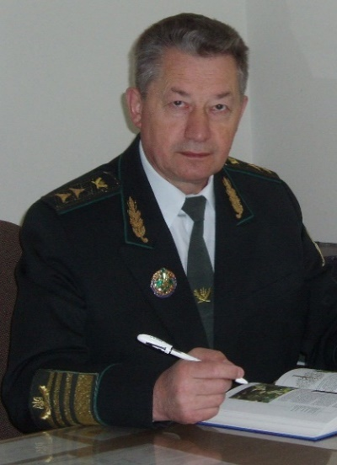 | G. Krynytskyy  Dr. of Biol. Sci., Prof., Vice-President of Forestry Academy of Sciences of Ukraine, Head of the Department of Forestry, Vice-Rector for scientific work of Ukrainian National Forestry University.
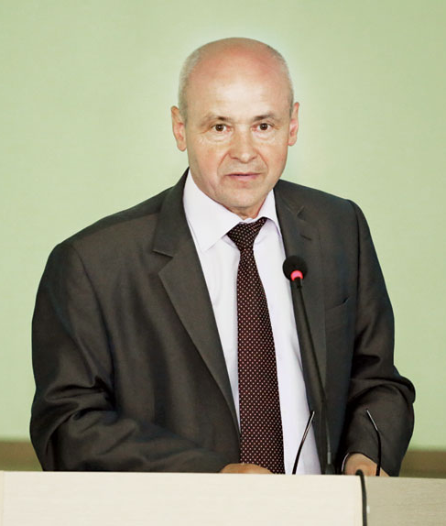 | V. Usenia  Dr. of Agric. Sci., Prof., Associate Member of NAS of Belarus, Deputy director for science work of Institute of Forest of NAS of Belarus.
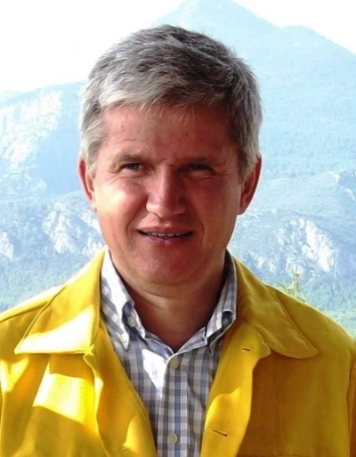 | S. Zibtsev  Dr. of Agric. Sci., Prof. of the Department of Forestry, Head of the Laboratory of Forest Pyrology, Director of Regional Eastern Europe Fire Monitoring Center (REEFMC).
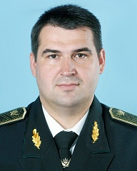 | R. Vasylyshyn  Dr. of Agric. Sci., Prof. of the Department of Forest Mensuration and Forest Management, Director of Research Institute of Silviculture and Decorative Horticulture, Academician of Forestry Academy of Sciences of Ukraine.
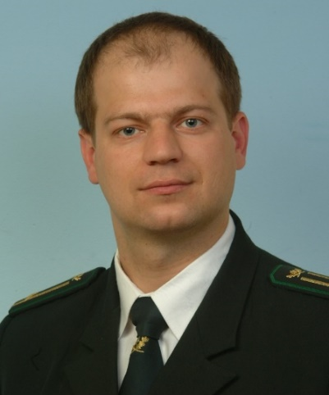 | A. Bilous  Dr. of Agric. Sci., Acting Head of the Department of Forest Mensuration and Forest Management.

