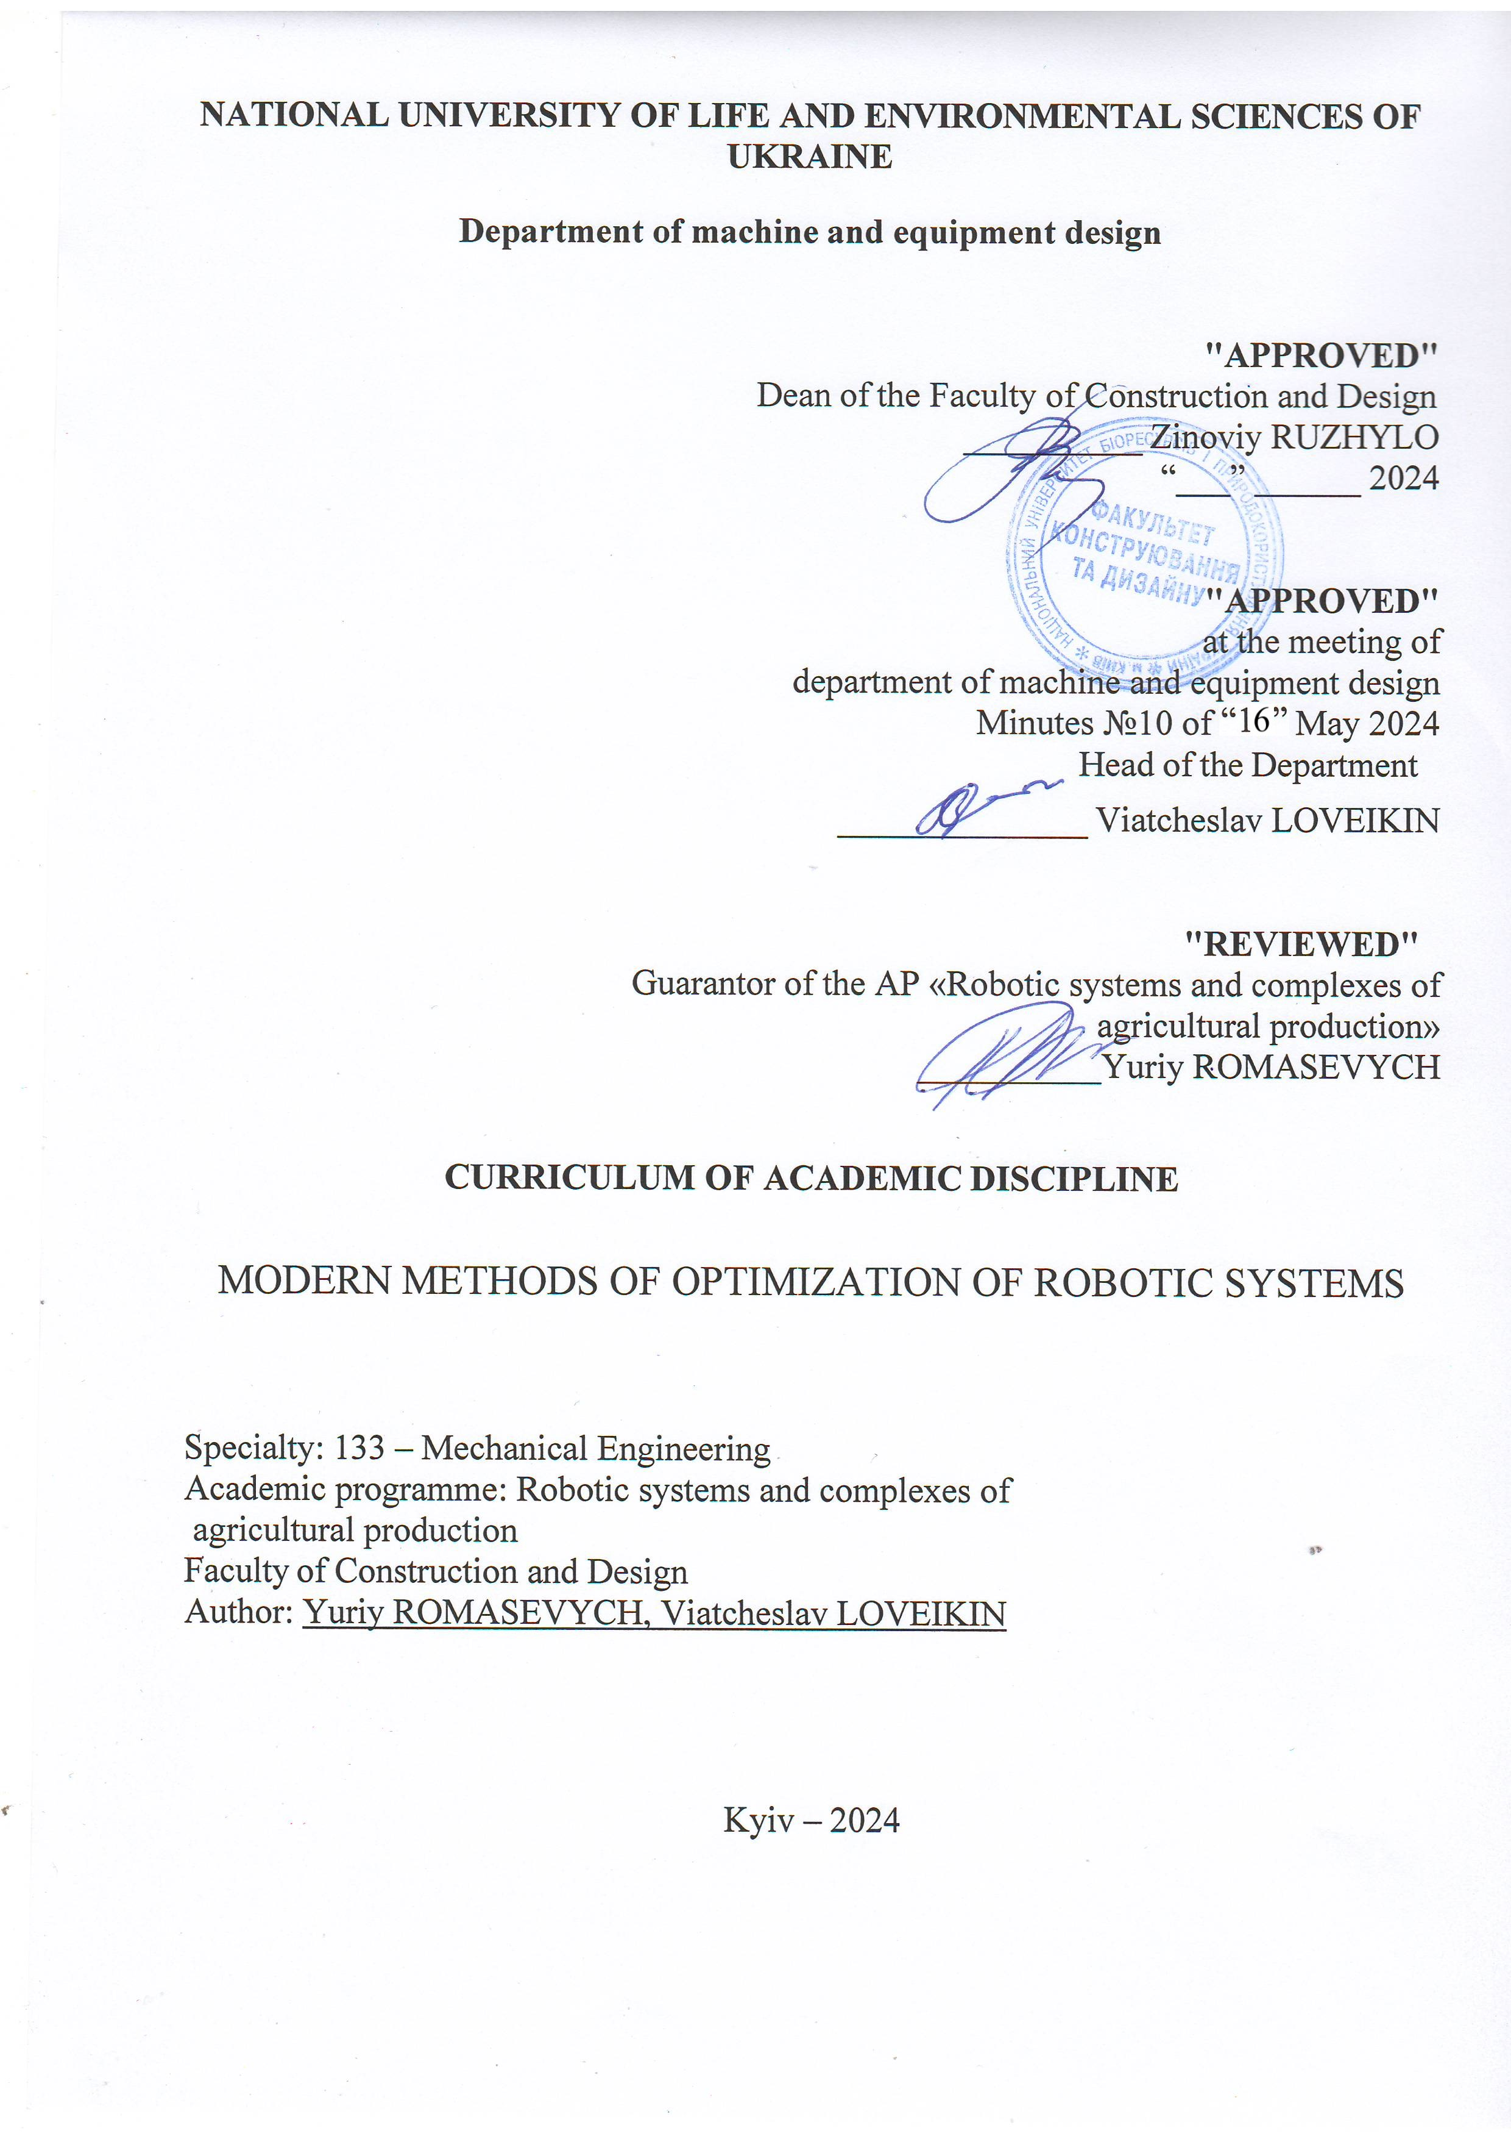
NATIONAL UNIVERSITY OF LIFE AND ENVIRONMENTAL SCIENCES OF UKRAINE

Department of machine and equipment design

"APPROVED"
Dean of the Faculty of Construction and Design
__________ Zinoviy RUZHYLO
“___” ______ 2024

"APPROVED"
at the meeting of
department of machine and equipment design
Minutes №10 of “16” May 2024
Head of the Department
______________ Viatcheslav LOVEIKIN

"REVIEWED"
Guarantor of the AP «Robotic systems and complexes of
agricultural production»
____________Yuriy ROMASEVYCH

CURRICULUM OF ACADEMIC DISCIPLINE

MODERN METHODS OF OPTIMIZATION OF ROBOTIC SYSTEMS

Specialty: 133 – Mechanical Engineering
Academic programme: Robotic systems and complexes of
agricultural production
Faculty of Construction and Design
Author: Yuriy ROMASEVYCH, Viatcheslav LOVEIKIN

Kyiv – 2024

Description of the discipline
MODERN METHODS OF OPTIMIZATION OF ROBOTIC SYSTEMS

Academic degree, specialty, academic programme
Academic degree | master
Specialty | 133 – Mechanical Engineering
Academic programme | Robotic systems and complexes of agricultural production
Characteristics of the discipline
Type | compulsory
Total number of hours | 150
Number of ECTS credits | 5
Number of modules | 3
Course project (work) (if any) | -
Form of assessment | exam
Indicators of the discipline
for full-time and part-time forms of university study
 | Full-time | Part-time
Year of study | 1 | -
Semester | 2
Lectures | 45 h. | -
Practical classes and seminars | - | -
Laboratory classes | 30 h. | -
Self-study | 75 h. | -
Number of hours per week for full-time students | 5 h. | -

Aim, objectives, competences and expected learning outcomes of the discipline

The aim of the discipline is to acquaint students with modern optimization methods and their application in various areas of mechanical engineering, in particular for robotic systems. The training course is aimed at forming in students a deep understanding of the theoretical aspects of optimization, as well as practical skills for their implementation.
Tasks of the discipline: review of modern optimization methods (genetic algorithms, simulation modeling, direct search methods, gradient-oriented methods, etc.), determination of the main advantages and disadvantages of each method; optimization application models for solving optimization problems of industrial mechanical engineering (synthesis of optimal laws of movement of forklifts and robotic systems, automatic control systems, training of artificial neural networks, etc.).
Competence acquisition:
integral competence: the ability to solve complex tasks and problems of industrial mechanical engineering, which involve research and/or innovation and are characterized by uncertainty of conditions and requirements.
general competences:
Ability to use information and communication technologies.
Ability to learn and master modern knowledge.
Ability to search, process and analyze information from various sources.
Ability to be critical and self-critical.
Ability to generate new ideas (creativity).
Ability to identify, pose and solve problems.
Ability to make informed decisions.
professional (special) competences:
SK3. The ability to create new equipment and technologies in the field of mechanical engineering.
SK4. Awareness of promising tasks of modern production aimed at meeting the needs of consumers, mastering the trends of innovative development of industry technologies.
SK7. The ability to use intelligent technologies to ensure the sustainable development of robotic systems of agricultural production
Program learning outcomes:
Knowledge and understanding of the basics of technological, fundamental and engineering sciences, which are the basis of industrial engineering and, in particular, agricultural engineering.
Knowledge and understanding of mechanics and mechanical engineering and prospects for their development.
To know and understand the processes of industrial mechanical engineering, to have skills in their practical use.
Carry out engineering calculations to solve complex problems and practical problems in industrial mechanical engineering.
Analyze engineering objects, processes and methods.
Search for the necessary scientific and technical information in available sources, in particular, in a foreign language, analyze and evaluate it.
Knowledge of production advantages and features of the application of robotic systems and complexes in the agricultural industry.

Programme and structure of the discipline for:
- full-time (part-time) form of study;
reduced full-time (part-time) form of study.

Modules and topics | Number of hours
Modules and topics | full-time
Modules and topics | total |  | including
Modules and topics |  |  | l | p | lab | ind | s.st | weeks
1 | 2 |  | 3 | 4 | 5 | 6 | 7 | 8
Module 1. General characteristics of optimization robotics problems and approaches to their solution
Topic 1. Formulation of the optimization problem | 14 |  | 6 | - | - | - | 8 | 1-2
Topic 2. Peculiarities of objective functions and problems with constraints | 26 |  | 6 | - | 4 | - | 16 | 2-3
Total for module 1 | 40 |  | 12 | - | 4 | - | 24 | -
Module 2. Methods of solving optimization robotics problems
Topic 3. General characteristics of optimization methods. Features of optimization methods for robotics |  | 6 | 2 | - | 4 | - | - | 4-5
Topic 4. PSO optimization method and review of its application in robotics optimization |  | 24 | 5 | - | 8 | - | 11 | 5-7
Topic 5. DE optimization method and review of its application in robotics optimization |  | 16 | 4 | - | 4 | - | 8 | 8-9
Topic 6. GWO optimization method and review of its application in robotics optimization |  | 16 | 4 | - | 4 | - | 8 | 10-11
Topic 7. HS optimization method and review of its application in robotics optimization |  | 4 | 4 | - | - | - | - | 12
Total for module 2 |  | 66 | 19 | - | 20 | - | 27 | -
Module 3. Problems of optimization of robotic systems
Topic 8. Synthesis of optimal robot motion control systems |  | 18 | 6 | - | 4 | - | 8 | 12-13
Topic 9. Synthesis of optimal robot movement trajectories |  | 14 | 4 | - | 2 | - | 8 | 13-14
Topic 10. Optimal setting of frequency-controlled drives of robotic systems |  | 12 | 4 | - | - | - | 8 | 15
Total for module 3 |  | 44 | 14 | - | 6 | - | 24 | -
Total hours |  | 150 | 45 | - | 30 | - | 75 | -

Topics of laboratory (practical, seminar) classes
№ | Topic title | Hours
1 | Study of topological characteristics of objective functions of optimization robotics problem | 4
2 | Study of the influence of parameters of swarm dimension and the number of iterations on the efficiency of the PSO algorithm | 4
3 | Study of the operation of modifications of the PSO method with local connections between particles | 4
4 | Investigation of search properties of the DE differential evolution method and its modifications | 4
5 | A study of the search properties of the GWO gray wolf method | 4
6 | Comparative study of search properties of optimization algorithms of optimization robotics problem | 4
7 | Optimum setting of the PI controller of the motion of the robot link | 4
8 | Planning the optimal movement trajectory of the gripping body of the robot manipulation system | 2

Topics for self-study
№ | Topic title | Hours
1 | Formulation of the optimization problem for dynamic systems | 8
2 | Summary of optimization problems using penalty functions. Types of penalty functions | 8
3 | Non-differentiability of objective functions and approaches to optimization of non-differentiable objective functions | 8
4 | Modifications of the PSO method | 11
5 | Modifications of the DE method | 8
6 | Modifications of the GWO method | 8
7 | Types of restrictions and criteria for optimal control of robot movement | 8
8 | Approaches to solving the problem of synthesis of optimal robot movement trajectories | 8
9 | Mathematical models of frequency-controlled drives and optional settings of frequency converters | 8

Tools for assessing expected learning outcomes:
  - exam;
  - module tests;
  - abstracts;
  - presentation of laboratory and practical works.

Teaching methods:
When teaching this discipline, the following are used: verbal method (lecture, discussion, interview, etc.); practical method (laboratory classes); visual method (illustration method, demonstration method); work with educational and methodical literature (noting, summarizing, annotating, reviewing, writing an abstract); video method (remote, multimedia, web-oriented, etc.); independent work (task performance); individual research work of students of higher education.

Assessment methods
When teaching this discipline, the following are used: exam; oral or written survey; unit testing; abstracts; protection of laboratory works; presentations and speeches at scientific events.

- Distribution of points received by students
The assessment of students’ knowledge and skills is conducted by means of a 100-point scale and is converted into national grades according to Table 1 of the current Exam and Credit Regulations at NULES of Ukraine.

Student’s rating, points | National grading of exams and credits
Student’s rating, points | exams | credits
90-100 | excellent | pass
74-89 | good | pass
60-73 | satisfactorily | pass
0-59 | unsatisfactorily | fail

To determine a student’s rating in the discipline RDIS (up to 100 points), the received assessment rating RA (up to 30 points) is added to the academic performance raiting RAP (up to 70 points): RDIS = RAP + RA.

Teaching and learning aids
- textbooks, manuals, tutorials;
- guidelines for studying a discipline by full-time and part-time students.

Recommended sources of information
- Л.Р. Ладієва. Методи оптимізації та пошуку оптимальних рішень. Навчальний посібник. КПІ ім. Ігоря Сікорського. 2023. - 73 с.
- Н.В. Бурєннікова, О.В. Зелінська, І.М. Ушкаленко, Ю.Ю. Бурєнніков. Оптимізаційні методи та моделі: Навчальний посібник. Вінниця: ВНТУ, 2019. – 121 с.
- Н.Е. Кондрук, М.М. Маляр. Багатокритеріальна оптимізація лінійних систем: Навчальний посібник. Ужгород: РА “АУТДОР-ШАРК”, 2019. – 76 с.
- Ю.М. Кузнєцов, Б.І. Придальний Теорія технічних систем в аспектах досліджень та технічної творчості. − Луцьк: Вежа-Друк, 2023. – 284 с.
- Mathematical optimization [Електронний ресурс] – Режим доступу до ресурсу: https://en.wikipedia.org/wiki/Mathematical_optimization
- optimization [Електронний ресурс] – Режим доступу до ресурсу: https://www.britannica.com/science/optimization
- Newton's method in optimization [Електронний ресурс] – Режим доступу до ресурсу: https://en.wikipedia.org/wiki/Newton%27s_method_in_optimization

