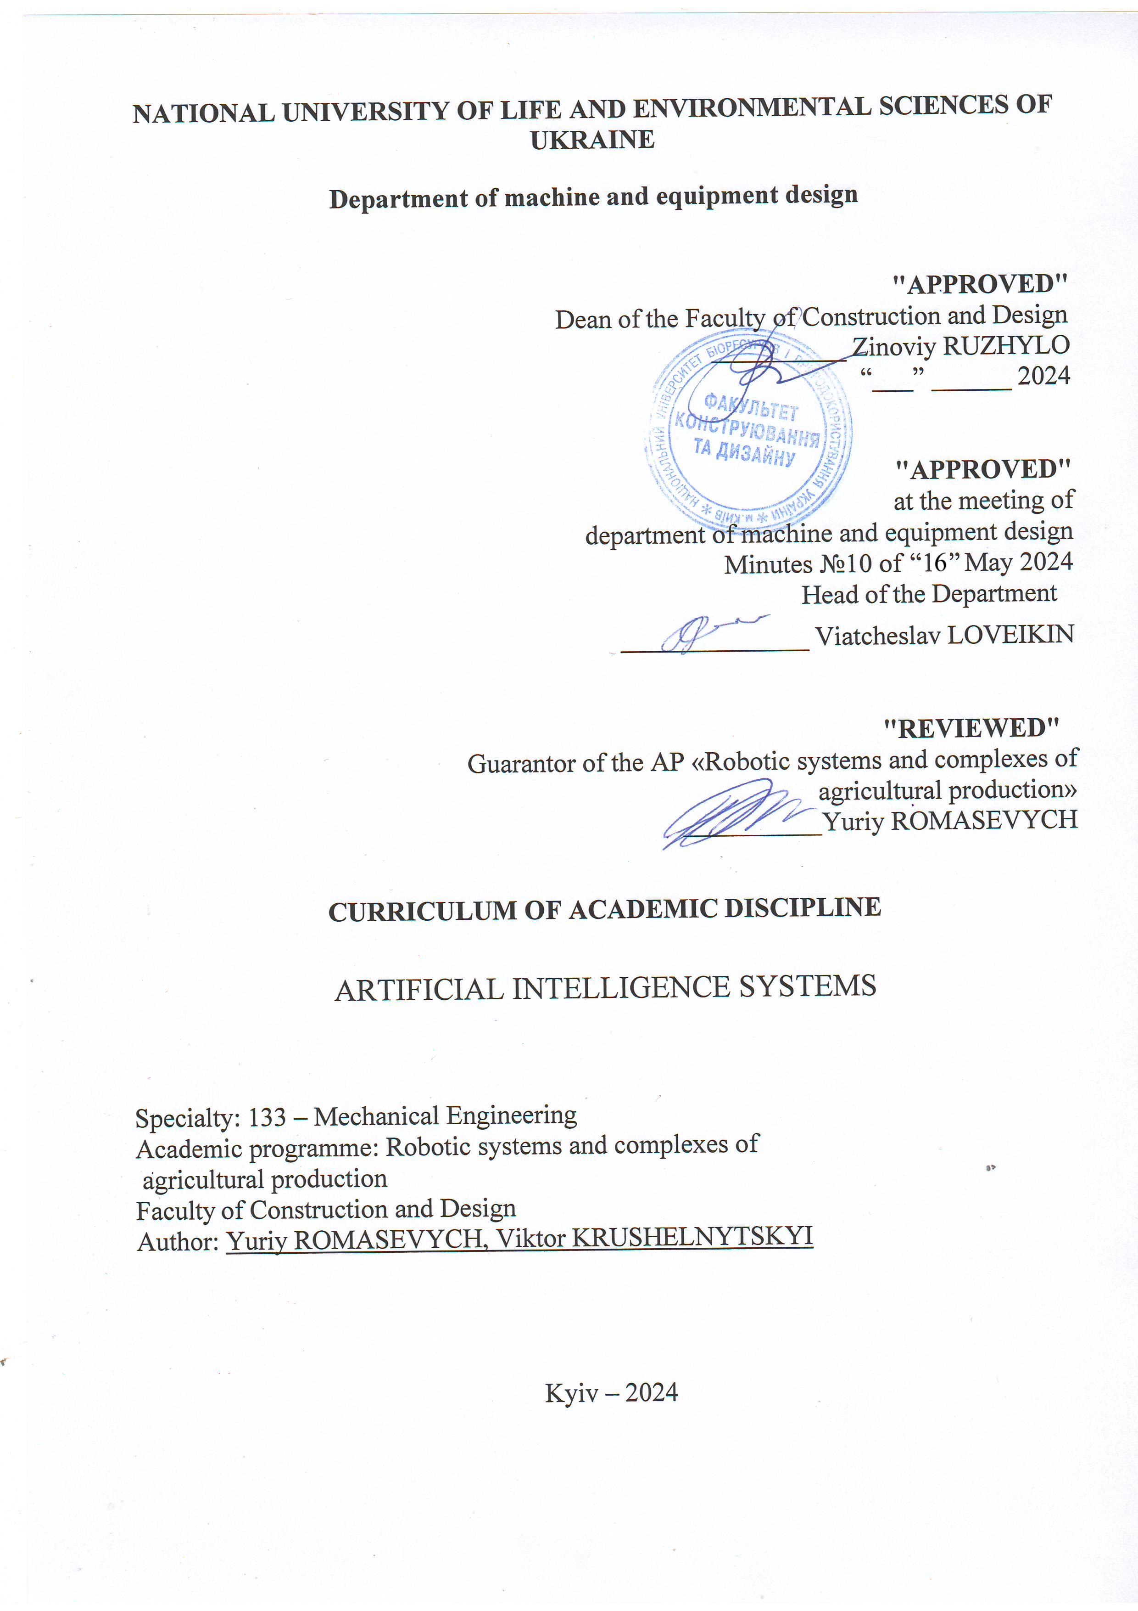
NATIONAL UNIVERSITY OF LIFE AND ENVIRONMENTAL SCIENCES OF UKRAINE

Department of machine and equipment design

"APPROVED"
Dean of the Faculty of Construction and Design
__________ Zinoviy RUZHYLO
“___” ______ 2024

"APPROVED"
at the meeting of
department of machine and equipment design
Minutes №10 of “16” May 2024
Head of the Department
______________ Viatcheslav LOVEIKIN

"REVIEWED"
Guarantor of the AP «Robotic systems and complexes of
agricultural production»
____________Yuriy ROMASEVYCH

CURRICULUM OF ACADEMIC DISCIPLINE

ARTIFICIAL INTELLIGENCE SYSTEMS

Specialty: 133 – Mechanical Engineering
Academic programme: Robotic systems and complexes of
agricultural production
Faculty of Construction and Design
Author: Yuriy ROMASEVYCH, Viktor KRUSHELNYTSKYI

Kyiv – 2024

Description of the discipline
ARTIFICIAL INTELLIGENCE SYSTEMS

Academic degree, specialty, academic programme
Academic degree | master
Specialty | 133 – Mechanical Engineering
Academic programme | Robotic systems and complexes of agricultural production
Characteristics of the discipline
Type | compulsory
Total number of hours | 210
Number of ECTS credits | 7
Number of modules | 4
Course project (work) (if any) | -
Form of assessment | Exam, credit, сoursework
Indicators of the discipline
for full-time and part-time forms of university study
 | Full-time | Part-time
Year of study | 1 | -
Semester | 1, 2
Lectures | 60 h. | -
Practical classes and seminars | - | -
Laboratory classes | 60 h. | -
Self-study | 60 h. | -
Number of hours per week for full-time students | 4 h.  2 h. | -

Aim, objectives, competences and expected learning outcomes of the discipline
Artificial intelligence systems (AIS) play an extremely important role in the development of robotics. They give robots the ability to adapt to new situations, learn from data, and make decisions, allowing them to become more efficient, flexible, and useful in a variety of fields, including agriculture.
Here are a few aspects of the importance of artificial intelligence systems in the field of robotics: 1) autonomy and understanding of the environment (AIS help robots understand their environment by processing sensory data such as video, audio and touch sensors. This allows robots to learn and make decisions based on the collected data ); 2 recognition of objects and planning of actions (AIS allows robots to recognize objects, people and other robots in their environment. Based on this information, they can develop optimal action strategies to achieve specific goals); 3) learning and adaptation (SSIs can train robots based on a large amount of data, which allows robots to improve their skills over time. This is especially important in situations where it is impossible to predict all possible options); 4) collaborative work with humans (AIS help robots to effectively interact with humans, understand their instructions and respond to their needs. This can find application in agricultural production lines and many other areas); 5) increasing safety and reducing risks (AIS allow robots to analyze complex situations, predict possible dangers and risks, as well as make decisions to prevent them); 6) effective solution of tasks (application of SSI helps robots to perform tasks more efficiently due to optimization of work processes, distribution of resources and adaptation to changing conditions); 7) research and reconnaissance (UAV robots can be used to explore dangerous or hard-to-reach areas, where they can collect data and transmit it to remote operators).
In general, AIS and deep learning open up new possibilities for robotics, making robots more adaptable, intelligent and useful in various areas of production, including agricultural production.
The goal of the discipline is the formation of theoretical understanding and practical skills in the development of SSI and their application in the field of robotics.
The tasks of the discipline consist in teaching: the main theoretical principles on which SSI is based, their application to the development of control systems for the movement of robots, planning their trajectory, processing sensory information, etc.; the use of software for the implementation of AIS in the field of robotics.
Competence acquisition:
integral competence: the ability to solve complex tasks and problems of industrial mechanical engineering, which involve research and/or innovation and are characterized by uncertainty of conditions and requirements.
general competences:
Ability to use information and communication technologies.
Ability to learn and master modern knowledge.
Ability to search, process and analyze information from various sources.
Ability to be critical and self-critical.
Ability to generate new ideas (creativity).
Ability to identify, pose and solve problems.
Ability to make informed decisions.
professional (special) competences:
The ability to create new equipment and technologies in the field of mechanical engineering.
The ability to develop and implement plans and projects in the field of mechanical engineering, in particular the development of robots and robotic systems, and related activities, to carry out relevant business activities.
The ability to design, research and use robotic systems and complexes to meet the needs of agricultural production.
The ability to use intelligent technologies to ensure the sustainable development of robotic systems of agricultural production.
Program learning outcomes:
Knowledge and understanding of mechanics and mechanical engineering and their development prospects.
Knowledge of production advantages and features of the use of robotic systems and complexes in the agricultural sector of production.

Programme and structure of the discipline for:
- full-time (part-time) form of study;
reduced full-time (part-time) form of study.

Modules and topics | Number of hours
Modules and topics | full-time
Modules and topics | total |  | including
Modules and topics |  |  | l | p | lab | ind | s.st | weeks
1 | 2 |  | 3 | 4 | 5 | 6 | 7 | 8
Module 1. Basics of ANN architectures and their application in robotics
Topic 1. Introduction. Basic concepts and applications of ANNs for robotics | 13 |  | 4 | - | 4 | - | 5 | 1-3
Topic 2. Mathematical basics of ANN operation | 15 |  | 6 | - | 4 | - | 5 | 3-6
Topic 3. Special ANNs for robots | 17 |  | 5 | - | 7 | - | 5 | 6-8
Total for module 1 | 45 |  | 15 | - | 15 | - | 15 | -
Module 2. Approaches to ANN training
Topic 4. ANN training "with a teacher" and correspond robotics problems |  | 17 | 5 | - | 7 | - | 5 | 8-10
Topic 5. ANN training "with reinforcement" and correspond robotics problems |  | 18 | 5 | - | 8 | - | 5 | 11-13
Topic 6. Backpropagation method |  | 10 | 5 | - | - | - | 5 | 13-15
Total for module 2 |  | 45 | 15 | - | 15 | - | 15 | -
Module 3. Development of fuzzy systems for robotics problems
Topic 7. General concepts of fuzzy logic and its use |  | 18 | 5 | - | 5 | - | 7 | 1-4
Topic 8. Development of fuzzy control systems for robot system movement |  | 27 | 10 | - | 10 | - | 8 | 4-8
Total for module 3 |  | 45 | 15 | - | 15 | - | 15
Module 4. Application of artificial intelligence systems in robotics
Topic 9. Planning the trajectories of the movement of robotic systems |  | 9 | 4 | - | - | - | 5 | 8-9
Topic 10. Synthesis of optimal neurocontrollers of robot link movement |  | 20 | 6 | - | 9 | - | 5 | 10-13
Topic 11. Prediction models of time series for development of mathematical models of robots |  | 16 | 5 | - | 6 | - | 5 | 13-15
Total for module 4 |  | 45 | 15 | - | 15 | - | 15 | -
Coursework |  | 30 | - | - | - | - | - | -
Total hours |  | 180 | 60 |  | 60 |  | 60 | -

Topics of laboratory (practical, seminar) classes
№ | Topic title | Hours
1 | Preliminary data preparation | 4
2 | Creation of a classifier based on a perceptron | 2
3 | Multilayer perceptron | 2
4 | Study of recurrent ANNs | 7
6 | Classification indicators for assessing the quality of forecasts | 4
7 | Cross-validation to assess the quality of the classifier | 3
8 | Evaluation of the quality of models in classification tasks | 4
9 | Methods of cross-validation | 4
10 | Operations on fuzzy sets | 6
11 | Fuzzification and defuzzification in a fuzzy controller | 2
12 | Unclear control system | 7
13 | Synthesis of optimal neurocontrollers for linear systems (robot drive) | 4
14 | Synthesis of optimal neurocontrollers for nonlinear systems (robot link) | 5
15 | Research of predictive properties of recurrent ANNs on time series for development of mathematical models of robots | 6

Topics for self-study
№ | Topic title | Hours
1 | Analysis of areas of application of ANNs in robotics and agricultural production | 5
2 | Mathematical operations in ANNs | 5
3 | Recurrent ANNs | 5
4 | Preparation of data for training ANNs according to the “with teacher” paradigm | 5
5 | Application of gradient-free optimization methods for training ANNs according to the “reinforcement” paradigm | 5
6 | Generalization of the method of backpropagation of the error (the case of multilayer ANNs) | 5
7 | The properties of membership functions and the concept of term in fuzzy logic | 7
8 | Building a rule base for fuzzy control systems | 8
9 | Solving the problem of planning the optimal trajectory of the manipulator robot | 5
10 | Approaches to the synthesis of optimal neurocontrollers of underactuated robotic systems | 5

Tools for assessing expected learning outcomes:
  - exam;
  - credit;
  - module tests;
  - abstracts;
  - presentation of laboratory and practical works.

Teaching methods:
When teaching this discipline, the following are used: verbal method (lecture, discussion, interview, etc.); practical method (laboratory classes); visual method (illustration method, demonstration method); work with educational and methodical literature (noting, summarizing, annotating, reviewing, writing an abstract); video method (remote, multimedia, web-oriented, etc.); independent work (task performance); individual research work of students of higher education.

Assessment methods
When teaching this discipline, the following are used: exam; oral or written survey; unit testing; abstracts; protection of laboratory works; presentations and speeches at scientific events.

- Distribution of points received by students
The assessment of students’ knowledge and skills is conducted by means of a 100-point scale and is converted into national grades according to Table 1 of the current Exam and Credit Regulations at NULES of Ukraine.

Student’s rating, points | National grading of exams and credits
Student’s rating, points | exams | credits
90-100 | excellent | pass
74-89 | good | pass
60-73 | satisfactorily | pass
0-59 | unsatisfactorily | fail

To determine a student’s rating in the discipline RDIS (up to 100 points), the received assessment rating RA (up to 30 points) is added to the academic performance raiting RAP (up to 70 points): RDIS = RAP + RA.

Teaching and learning aids
- Electronic resource «Artificial Intelligence Systems», Digital portal of NULES of Ukraine / Yuriy Romasevych, Viktor Krushelnytsky – Access: https://elearn.nubip.edu.ua/course/view.php?id=5360;
- textbooks, manuals, tutorials;
- guidelines for studying a discipline by full-time and part-time students.

Recommended sources of information
- С.В. Ткаліченко. Штучні нейронні мережі: Навчальний посібник. – Кривий Ріг: Державний університет економіки і технологій, 2023. –150 с.
- Нейронні мережі: теорія та практика / С.О. Субботін. – Житомир : Вид. О. О. Євенок, 2020. – 184 с.
- Терейковський І. А. Штучні нейронні мережі: базові положення / І.А. Терейковський, Д. А. Бушуєв, Л. О. Терейковська. – Київ, 2022. – 123 с.
- Мехатроніка: підручник / В.С. Ловейкін, Ю.О. Ромасевич, В.В. Крушельницький. – К.: ЦП „Компрінт”, 2020. – 404 с.
- TensorFlow Core [Електронний ресурс] – Режим доступу до ресурсу: https://www.tensorflow.org/tutorials.
- The Python Tutorial [Електронний ресурс] – Режим доступу до ресурсу: https://docs.python.org/3/tutorial/index.html.
- Штучний інтелект [Електронний ресурс] – Режим доступу до ресурсу: https://uk.wikipedia.org/wiki/Штучний_інтелект.
- Штучна нейронна мережа [Електронний ресурс] – Режим доступу до ресурсу: https://uk.wikipedia.org/wiki/Штучна_нейронна_мережа.
- Нечітка логіка [Електронний ресурс] – Режим доступу до ресурсу: https://uk.wikipedia.org/wiki/Нечітка_логіка.

