Scientific Club "Veterinary Toxicology"

Work Plan and Schedule of the Scientific Club "Veterinary Toxicology" for the 2024-2025 Academic Year
Events | Date | Venue | Responsible Person
Familiarization with the department's scientific work. Preparation of the workplace for conducting chemical-toxicological studies of feeds, pathological material, and other environmental objects. Preparation of laboratory glassware and reagent solutions. | September | Room 217-218, Block D / Online | Hryhorii Boiko, Vadym Ishchenko
Detection and identification of long-term effects of veterinary medicinal products. Main detection methods and analysis of obtained results. | September | Room 217-218, Block D / Online | Vadym Ishchenko, Hryhorii Boiko
Mastering basic principles of testing and alternative methods for determining the toxicity of new medicinal products. Qualitative reactions for detecting toxicants. | October | Room 217-218, Block D / Online | Hryhorii Boiko
Toxicological control of nitrate content. | November | Room 217-218, Block D / Online | Vadym Ishchenko, Hryhorii Boiko
Antibiotic resistance. | November | Room 217-218, Block D / Online | Vadym Ishchenko, Hryhorii Boiko
Working with literature on determining the toxicity of medicinal products and feed additives. | December | Room 217-218, Block D / Online | Vadym Ishchenko, Hryhorii Boiko
Familiarization with basic requirements and provisions for preclinical studies of medicinal products and feed additives on laboratory animals. | February | Room 217-218, Block D / Online | Hryhorii Boiko, Vadym Ishchenko
Chemical-toxicological studies of substrates for qualitative detection and quantitative determination of toxicants. | March | Room 217-218, Block D / Online | Hryhorii Boiko, Vadym Ishchenko
Chemical-toxicological studies of substrates for qualitative detection and quantitative determination of toxicants. | April | Room 217-218, Block D / Online | Hryhorii Boiko, Vadym Ishchenko
Summarizing the club’s activities for the academic year. | May | Room 217-218, Block D / Online | Hryhorii Boiko, Vadym Ishchenko
Developing research skills according to the department’s scientific research plan. Individual work of supervisors with student club members. | February - May | Room 217-218, Block D / Online | Each supervisor works individually with student club members


Candidate of Veterinary Sciences, Associate Professor, Head of the Student Club:
Hryhorii Vasylovych Boiko

The Student Scientific Club "Veterinary Toxicology" traces its origins to September 1941, when, following the evacuation of the Kyiv Veterinary Institute to the city of Sverdlovsk (now Yekaterinburg), senior lecturer Serhii Vasylovych Bazhenov (later, from 1942, Candidate of Veterinary Sciences) became the head of two independent departments—Pharmacology and Toxicology—and established the club.
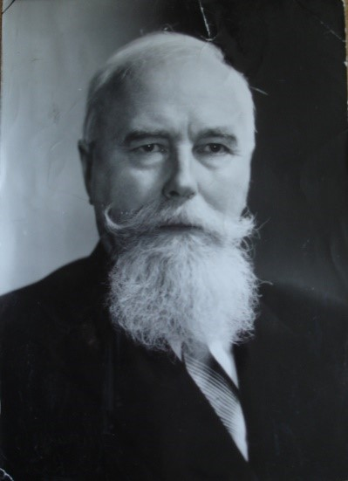
Upon the institute's return to Kyiv in 1948, the Department of Pharmacology and Toxicology was founded, with Associate Professor Bazhenov S.V. leading it until its merger with the Department of Pathophysiology in 1957 under the leadership of Professor Vashetko M.P.
In 1959, another departmental reorganization resulted in the creation of the Department of Pharmacology, Pathophysiology, and Parasitology, which Professor Bazhenov S.V. headed until 1979. That year, at Professor Bazhenov’s recommendation, Associate Professor Hryhorii Oleksandrovych Khmelnytskyi was appointed head of the Department of Pharmacology and Toxicology. Khmelnytskyi later became a Doctor of Veterinary Sciences (1981), Professor (1982), Corresponding Member (1990), and Academician (1993) of the National Academy of Agrarian Sciences of Ukraine. He was honored as a Distinguished Figure in Science and Technology of Ukraine (1998) and served as Director of the Animal Health Research Institute at the National University of Life and Environmental Sciences of Ukraine (2001–2009). Professor Khmelnytskyi consistently supported the activities of the student scientific club.
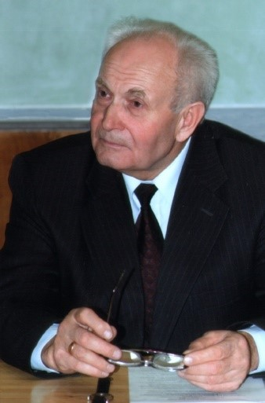
From 2006 to 2012, the club was led by Associate Professor Mykola Fedorovych Panko, a student of Serhii Vasylovych Bazhenov.
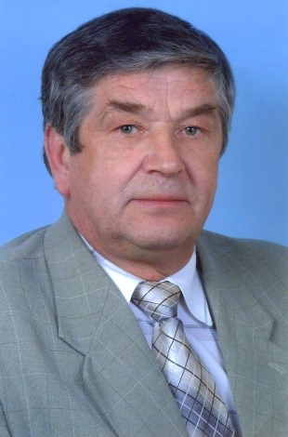

Since 2012, Hryhorii Vasylovych Boiko has been supervising the club.
The primary research focus, proposed by Professor Bazhenov S.V., centers on studying the toxicity of non-protein nitrogen compounds (urea, nitrates, and nitrites) and developing diagnostic, treatment, and prevention methods for poisoning in farm animals. This work was successfully continued under the guidance of Academician Khmelnytskyi H.O.
In recent years, club members have been actively addressing the issue of animal mycotoxicosis and have been involved in researching and implementing new antimicrobial, anti-inflammatory, and immunostimulatory agents into production.

