National university of life and environmental sciences of ukraine

Kyiv

16 Polkovnyka Potekhina Street,

03041

Ukraine

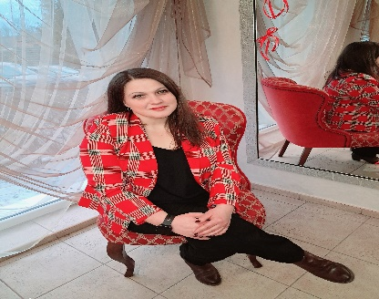

Ilchychyn Maria Mykhailivna

Tel..:+38(068)4707414

E-mail: mariyailchyn72@gmail.com

Faculty of Veterinary Medicine

Department of Physiology and of Vertebrates and Pharmacology

Specialty 211 - Veterinary Medicine

Dissertation Topic "Autonomic nervous regulation of milk production in cows under the influence of nanoaquachelates"

Scientific Director : Doctor of Veterinary Sciences, Professor Karpovskyi V.I.

Postgraduate Study Period: 1.09.2022.-1.09.2026.

Publications and theses:

1. Kravchuk S.V. ,Todoriuk V.B., Khymynets P.S., Hryshchuk I.A., Ilchyshyn M.M. Zhurenko O.V., Karpovskyi V.I., “Determination of heart rate variability as an indicator of the influence of the tone of the autonomic nervous system in pigs”.

International Scientific and Practical Conference “CURRENT PROBLEMS OF ANIMAL PHYSIOLOGY”

2. Hryshchuk I.A., Hryshchuk A.V , Todoruk V.b,.Ilchyshyn M.M. Zhurenko O.V., Karpovskyi V.I., “Total cholesterol content depending on the tone of the autonomic nervous system in cows.”

International Scientific and Practical Conference “CURRENT PROBLEMS OF ANIMAL PHYSIOLOGY.”

3. Karpovskyi V.I.,Ilchyshyn M.M. "Productivity of cows with different parameters of the tone of the autonomic nervous system"

4. S. O. SIDAShOVA., B. V. HUTYI., M. M. ILChYShYN., V. B. TODORIuK T., V. MARTYShchUK. "Structure of gonadal dysfunctions in cows with chronic gynecological pathologies"

5. Zhurenko O.V., Hryshchuk I.A., Karpovskyi V.I., Kryvoruchko D.I., Zhurenko V.V., Ilchyshen M.M., Todoriuk V.B., Karpovskyi V.V., Karpovskyi P.V., Hryshchuk A.V.

"UNSATURATED FATTY ACIDS IN COWS' MILK UNDER DIFFERENT VEGETATIVE REGULATION"

6. .Zhurenko O.V., Kulbako O.V., Hryshchuk I.A., Karpovskyi V.I., Kryvoruchko D.I., Zhurenko V.V., Ilchyshen M.M., Todoriuk V.B., Karpovskyi V.V., Karpovskyi P.V., Khymenets P.S., Kravchuk S.V., Hrelia R.V., Hryshchuk A.V., Boichuk B.I. “PROTEIN METABOLISM OF LAYING CHICKENS UNDER DIFFERENT TONE OF THE AUTONOMOUS NERVOUS SYSTEM”.

Participation in conferences:

1. International Scientific and Practical Conference of Scientists, Teachers and Postgraduate Students “Current Issues in Veterinary Medicine: Realities and Prospects – 2024”