National University of Life and Environmental Sciences

of Ukraine

03041, Kyiv, Ukraine,

16, Polkovnyka Potekhina str.

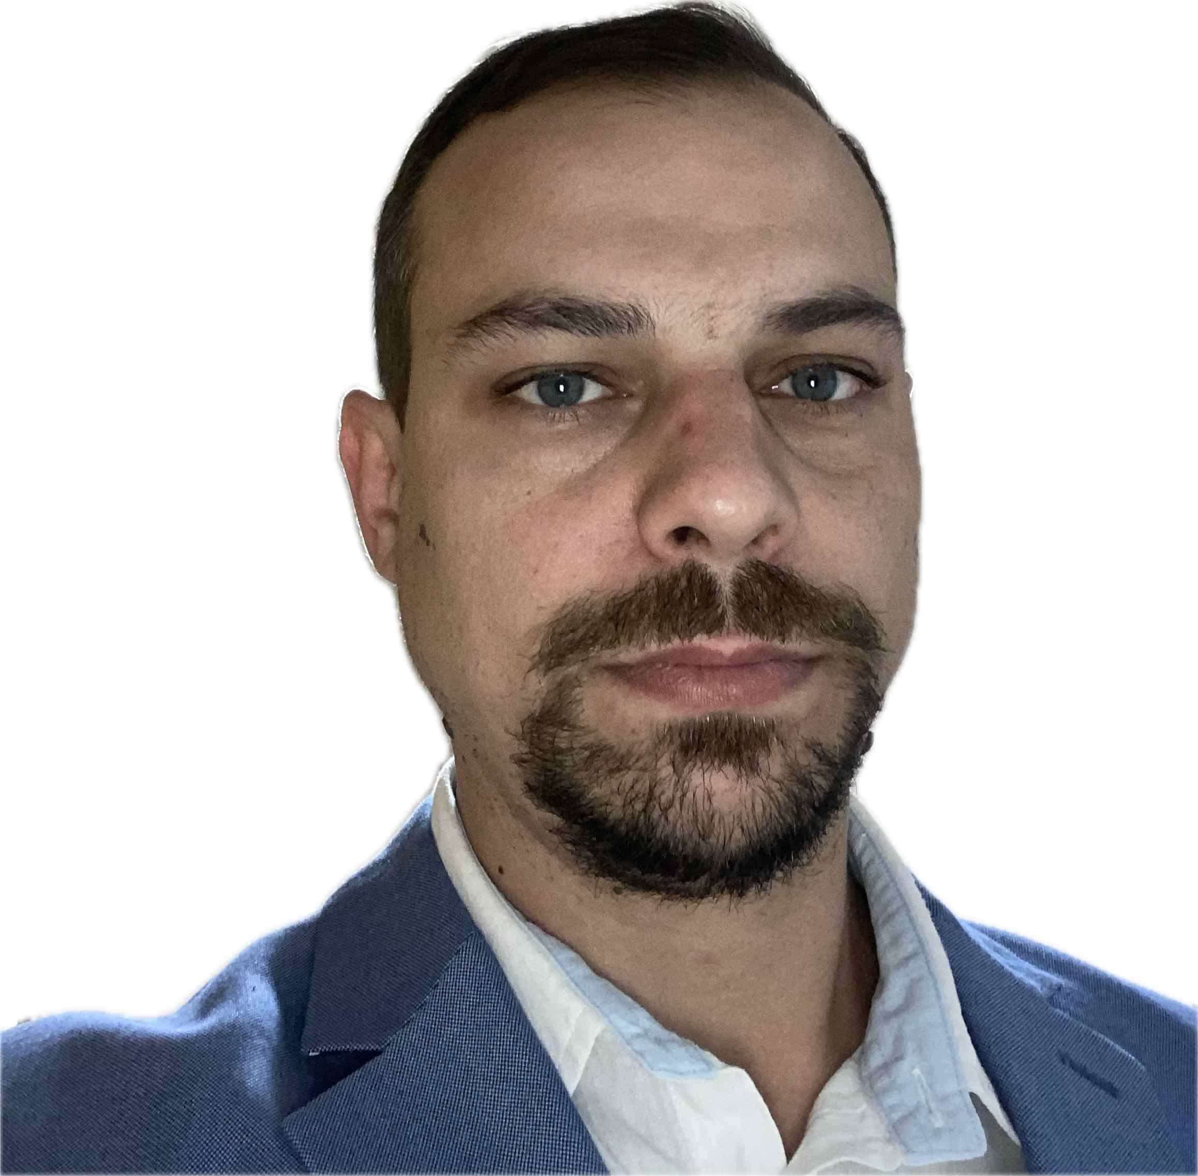

Khymynets

Pavlo Stepanovych

tel.:+38(099)675-25-67

e-mail: [polsivet@gmail.com](mailto:polsivet@gmail.com)

Faculty: Faculty of Veterinary Medicine of NUBIP of Ukraine

Department (division): vertebrate physiology and pharmacology

Specialty: 211 - Veterinary medicine

The theme of the dissertation: “Influence of the autonomic nervous system on the resistance and productivity of sows with the usage of iron nanoaqua chelates and germanium”

Supervisor: Doctor of Veterinary Sciences, Professor Karpovsky V.I.

Period of study at the postgraduate course: 1.09.2022.-1.09.2026.

**Publications and abstracts:**

**---KRAVCHUK S.V., TODORYUK V.B., KHIMINETS P.S., GRISHCHUK I.A., ILCHYSHYN M.M. ZHURENKO O.V., KARPOVSKY V.I., “ THE DETERMINATION OF HEART RATE VARIABILITY AS AN INDICATOR OF THE INFLUENCE OF THE AUTONOMIC NERVOUS SYSTEM TONE IN PIGS”. INTERNATIONAL SCIENTIFIC AND PRACTICAL CONFERENCE “ACTUAL PROBLEMS OF ANIMAL PHYSIOLOGY.**

**---KOVALCHUK O.O., TOMCHUK V.A., DANCHUK V.O., KHIMINETS P.S., GUTIY B.V., KRYVORUCHKO D.I, KARPOVSKY V.V. “THE EFFECT OF FERROUS AND GERMANIUM NANOCOMPOUNDS ON THE CONTENT OF CERULOPLASMIN IN THE BLOOD OF SOWS AND PIGLETS OBTAINED FROM THEM”. SCIENTIFIC BULLETIN, LVIV**

|  |
| --- |
| ***---KARPOVSKYI* V.I., ZHURENKO O.V., KHYMYNETS P.S., KRAVCHUK S.V. ETC. “THE EFFECT OF GERMANIUM AND FERRIC NANOAQUAHELATES ON THE MORPHOLOGICAL BLOOD PARAMETERS OF SOWS WITH DIFFERENT TONE OF THE AUTONOMIC NERVOUS SYSTEM”.**  **---Hurenko O.V., Kulbako O.V., Hryshchuk I.A., Karpovsky V.I., Kryvoruchko D.I., Zhurenko V.V., Ilchyshen M.M., Todoriuk V.B., Karpovsky V.V., Karpovsky P.V., Khymynets P.S., Kravchuk S.V., Grelya R.V., Hryshchuk A.V., Boychuk B.I. THE PROTEIN METABOLISM OF LAYING HENS AT DIFFERENT TONES OF THE AUTONOMATIC NERVOUS SYSTEM** |

**Participation in conferences:**

**1. International scientific and practical conference of scientists, lecturers and postgraduate students “ Actual issues of veterinary medicine: realities and prospects - 2024”**