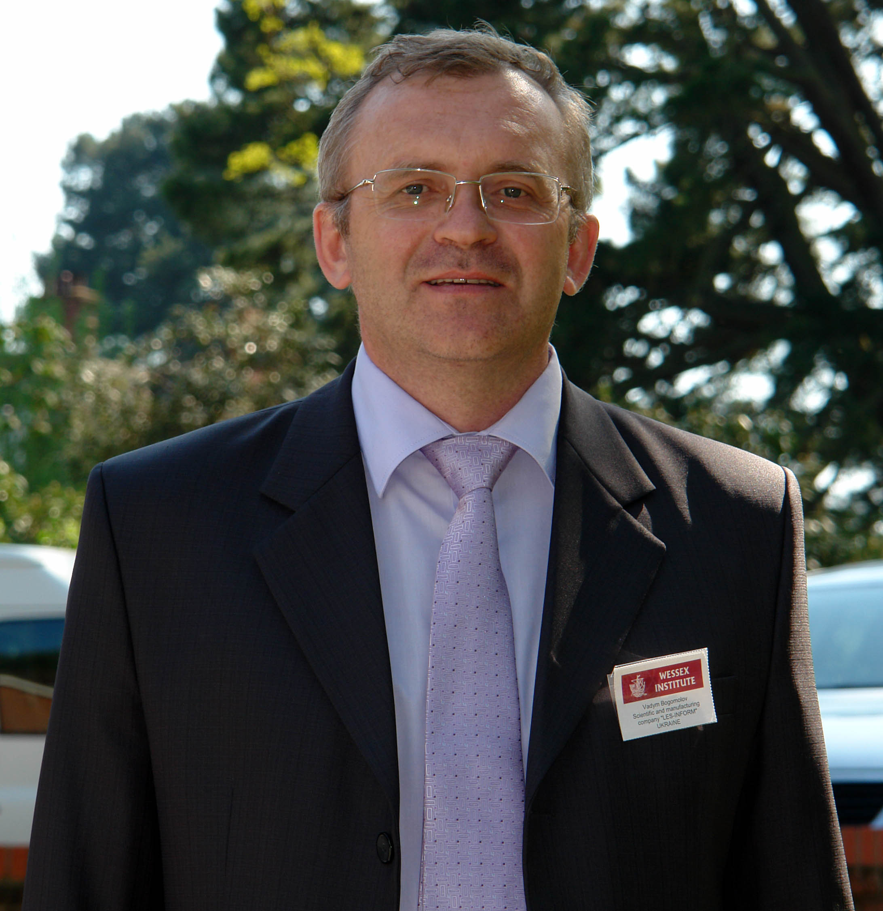

Vadym Bogomolov

Curriculum vitae
Date of birth: | 1962
Education: | 2005 - extension courses on GESmallworld solutions in Warsaw  2002-2004 – English language courses up to Advanced level.  1992 – extension courses on programming languages C, Pascal and Foxbase  1979-1984 – Kharkiv State University. Specialty: Geology  http://www.univer.kharkov.ua
Languages: | - Ukrainian, Russian, English
Jobs: | 2015-2020 CTO LIS-INFORM Ltd.  2004-2015 Head of division “GIS support of forest management” in Kharkiv forest management enterprise  1996 – 2004 – senior researcher in laboratory “Advanced information technologies” of Ukrainian Research Institute of forestry and forest melioration  https://uriffm.org.ua/struktura/laboratoriya-novyh-informaciynyh-tehnologiy  1995 – project coordinator and developer during developing salary accounting software on a Ukrainian factory  1993-1994 - programmer at gold mining enterprise  1988 – 1991 manager of geological exploration at gold mining enterprise  1984 – 1988 geologist in geological survey
Computer skills: | - DBMS – Postgresql, Mysql, GESmallworld,  - Programming languages: C#, Python, Magik  - GIS software – QGIS, Mapinfo, Erdas Imagine  - Experience with design tools and techniques including UML, case tools  - HTML, Javascript, CSS, Bootstrap  - GE Smallworld – Magik application development experience, expert with CASE, ACE, Style system
Chosen Proffesional Experiences: | - Developer of the geoportal “Ukrainian Forest” 2016-2020 https://foresty.org.ua  - Project coordinator and programmer of Decision Support System in fire extinguishing using IP-cameras and GPS-equipment for some Ukrainian forestry enterprises 2011-2016  - Project coordinator and programmer of GPS-tracking system using WEB-interface in forestry 2015-2016  - Developing module for predicting of radiation exposure doses of forest firefighters during suppression of wildfires in the Chornobyl Exclusion Zone (developed in the framework of an OSCE project) – 2015  http://www.osce.org/secretariat/194016  - Participating (Geoinformatics and Remote Sensing) in EU project Streams-2-Supress-Fires (utilizing stream waters in the suppression of forest fires with help of new technologies) 2013-2015  https://www.researchgate.net/publication/303376371_An_integrated_approach_for_mapping_fire_suppression_difficulty_in_three_different_ecosystems_of_Eastern_Europe  - Project coordinator in project “Developing computerized 3D geological model of gas deposit 2009-2010”  - Project Manager, system analyst and programmer in developing and implementation Smallworld-based GIS for forest management enterprise (2001 – 2007)  - Project coordinator and programmer in GIS project for regional department of Ukrainian Cadastre System (2007-2008)
Visiting Activity | Reporter on third international conference on modelling, monitoring and management of forest fires Organised by  Wessex Institute of Technology, UK. Monitoring network-based infrastructure for forest fire detection.  http://www.wessex.ac.uk/12-conferences/forest-fires-2012.html
ORSID iD | https://orcid.org/0000-0001-9469-1487

