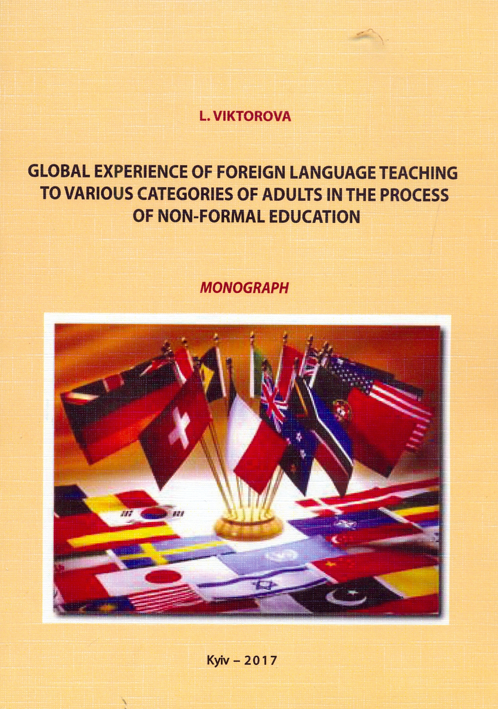

Global experience of foreign language teaching to various categories of adults in the process of non-formal education: monograph / L.V. Viktorova – K. : Milenium, 2017. – 186 p.
In the monograph the essential characteristics of the pedagogical process of foreign language education in USA, Germany, France, UK, Canada, Austria and others are analyzed.
It is defined that common global tendencies of foreign language education and strategies of teaching quality management include: multilingualism as a concentrated expression of policy and action program aimed to preserve linguistic diversity, social and cultural integration in order to obtain high level of linguistic harmony, build intercultural dialogue, elaborate intercultural tolerance that is realized by means of developing language strategies and competencies; lifelong learning of foreign languages; improving and implementation of metacognitive techniques; cognitive, social and emotive strategies; methods of memorizing information; change of computer-assisted language learning technologies (CALL) into mobile-assisted language learning technologies (MALI.).
For academic staff, post-graduate students, students, politicians of scientific and educational sphere.

