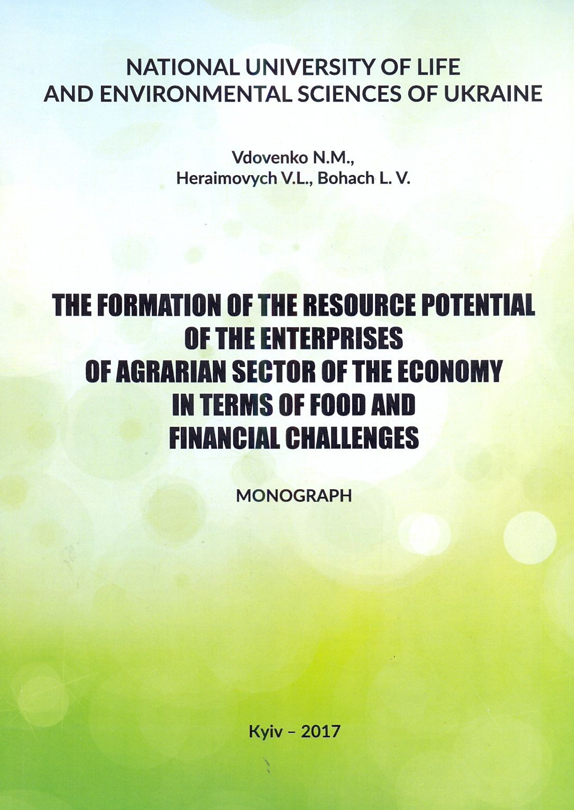

Vdovenko N. M., Heraimovych V. L., Bohach L. V.
The formation of the resource potential of the enterprises of agrarian sector of the economy in terms of food and financial challenges: Monograph. – K.: TsP “KOMPRYNT”, 2017. – 188 s.

The monograph in the context of the new conditions of food and financial challenges examines theoretical, methodological, methodical and practical aspects of agricultural enterprises effective resource potential formation. For scientists, educators, graduate students, students, business professionals and owners in the agricultural sphere.

