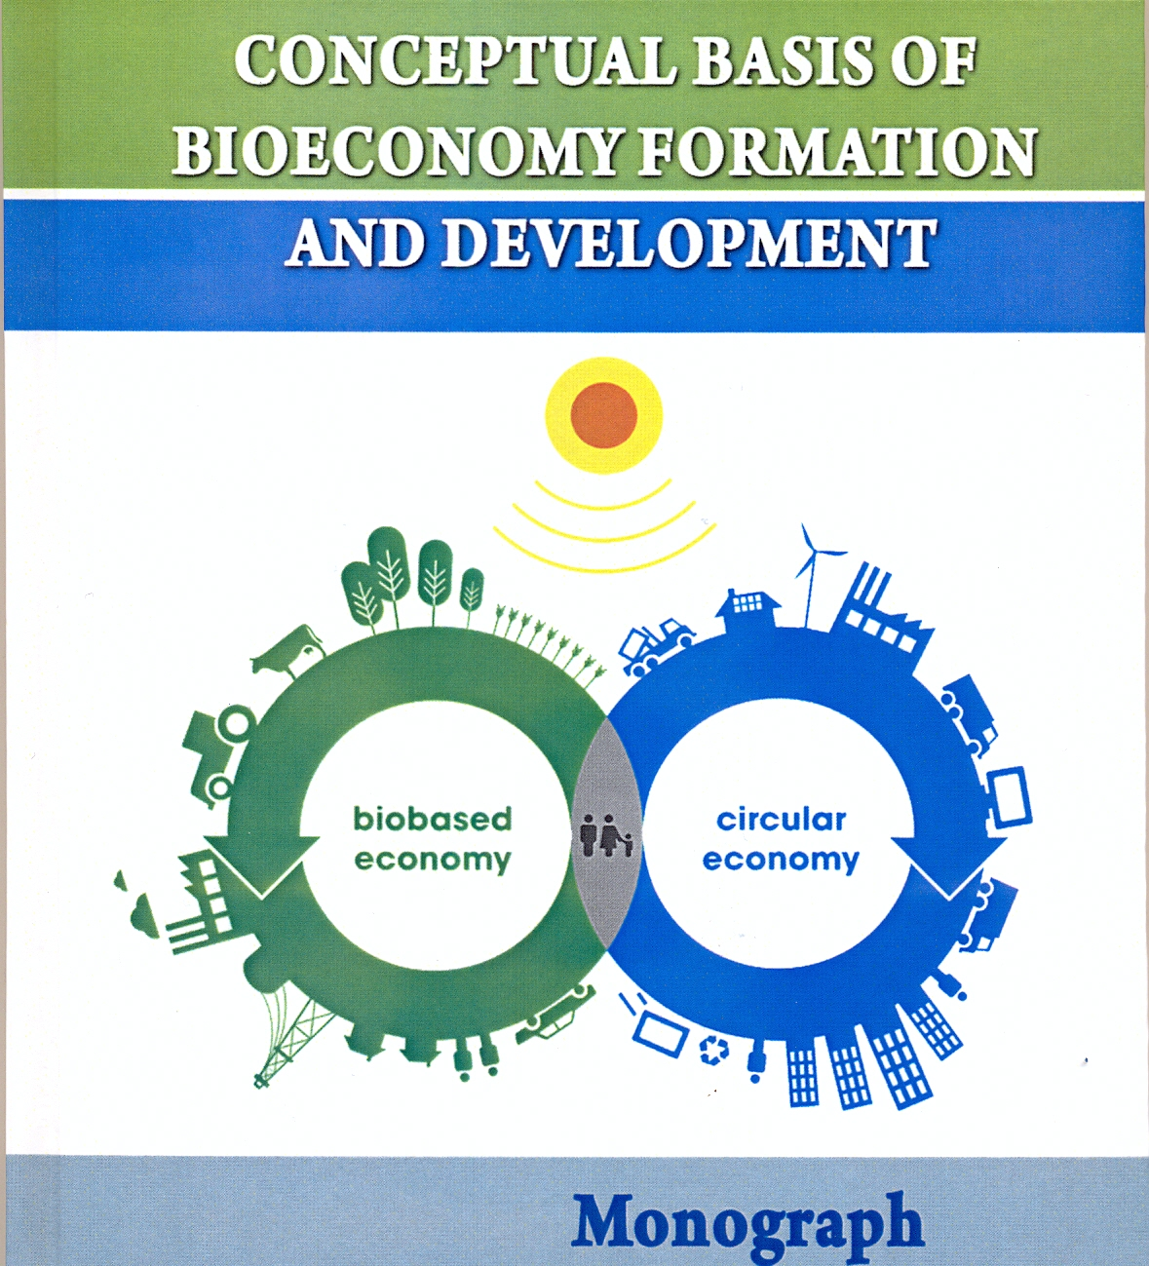

УДK 338:662.763.3:339.9
C 54 Conceptual basis of bioeconomy formaton and development: Monograph / M. P. Talavyria, V. V. Baidala, O. O. Riabchenko, V. V. Lymar, M. V. Dobrivska, O. M. Talavyria. – Nizhyn: PP Lysenko M. M., 2017. – 152 c.

