Форма № Н - 3.04

NATIONAL UNIVERSITY OF LIFE AND ENVEROMENTAL SCIENCES OF UKRAINE
Department ahrobiotehnology

"APPROVED"
Dean protection products, Biotechnology and Ecology
Dolya M.M.
«____»________________ 2015

Reviewed and approved
on meeting of department __________
Protocol № ____ of "____" ____ 2015
Head of Department
Lisovyi M.M.

WORKER EDUCATIONAL COMPLEX
"Biotechnology in agriculture"

Field of knowledge _
Direction of training 8.051401 "Biotechnology"________________
Spatiality
Specialization
Faculty Protection products, Biotechnology and Ecology
Developers: d. a. s., s. r. f. Lisovyi M.M., c. a. s., a. p. Antipov O.I.

KYIV-2015

NATIONAL UNIVERSITY OF LIFE AND ENVEROMENTAL SCIENCES OF UKRAINE
Department ahrobiotehnology

"APPROVED"
Dean protection products, Biotechnology and Ecology
Dolya M.M.
«____»________________ 2015

Reviewed and approved
on meeting of department __________
Protocol № ____ of "____" ____ 2015
Head of Department
Lisovyi M.M.

WORKER EDUCATIONAL PROGRAM
"Biotechnology in agriculture"

Field of knowledge _
Direction of training 8.051401 "Biotechnology"________________
Spatiality
Specialization
Faculty Protection products, Biotechnology and Ecology
Developers: d. a. s., s. r. f. Lisovyi M.M., c. a. s., a. p. Antipov O.I.

KYIV-2015

- Characterization OF DISCIPLINE
"Biotechnology in agriculture"

Field of knowledge, direction of training, specialty, qualification level
Educational qualification | "Master"
Direction of training
Specialty | 8.051401 "Biotechnology"
Characteristics of discipline

Kind | compulsory
Total amount of hours | 98
Amount of credits, corresponding to ЕСТS | 3
Modules | 3
Type of control: | test
Structure of discipline for full-time and part-time students

 | Internal students | External students
Year of training | 1
Semester | 1
Lectures | 15
Practical, seminars
Laboratory work
Self-instruction under direction | 83
Individual tasks
Amount of hours on a week for internal student  auditory  self-instruction | 2 год.

1.1. The task of the discipline
Purpose: the study of discipline allows us to consider the use of biotechnology applied comprehensively, taking into account the urgent needs of agricultural production and new promising developments ahrobiotehnolohiyi.
Objective: formation of students' system of theoretical and practical knowledge to ensure the implementation, production and exploitation of applied biotechnology in agriculture in a real production environment farm and regional bio-laboratories and modern methodological approaches to the development and improvement of appropriate biotechnology and engineering solutions.
As a result of the discipline the student should know:
- Classification and basic characteristics of biotechnological agents used for the implementation of existing and emerging applications of biotechnology in agriculture;
- Technological regimes and technical equipment for the main applications of biotechnological processes in agricultural production;
- For biological products and biotechnological characteristics that allowed for use in biological crop production;
- Design methodology and calculation of basic biotechnology and structural indicators processes applied biotechnology and cultivation and fermentation devices (microbiological reactors) for their implementation;
- Agri-environmental problems, the main requirements of biological safety when using the applications of biotechnology in agriculture;
- Technical specifications biotechnological processes methane fermentation, vermykompostuvannya, production of protein feed additives, regional production entomological and microbiological plant protection agents, etc;
- Methods and means of research aimed at further improving the application of biotechnological processes in agriculture.
After studying the discipline program the student should be able to:
- Plan, organize and operate the production of biologically active fertilizers and biological products;
- Identify and evaluate biotechnology and physical and chemical properties of raw materials, end products and biotechnological agents;
- Develop technological projects using applied biotechnologies concerning the conditions of particular agricultural enterprises:
- Identify problems biotechnological industries and to ensure their removal together with specialists of compatible industries (electricity, experts on the TRC and A, mechanics, plumbers, etc.);
- Formulate objectives for the development of new applications and improve existing biotechnology for their implementation according to the needs of the industry on the basis of commercial effect;
- Conduct scientific, theoretical and experimental research to further improve the application of biotech processes in agriculture.
2. The program of the course
- Full term full-time (part-time) form of study;
- Short term agenda (correspondence) learning.
Names of modules and themes | Amounts of hours
Names of modules and themes | Internal |  |  |  |  |  |  | External
Names of modules and themes | Common amount | including |  |  |  |  |  | Common amount | including
Names of modules and themes | Common amount | Lect. | P. |  | Labor. | Self-work | Self-work under direction | Common amount | Lect. | P. | Labor | Self-work | Self-work under direction
1 | 2 | 3 | 4 |  | 5 | 6 | 7 | 8 | 9 | 10 | 11 | 12 | 13
Module 1. Formation of virology as a science and structural property of viruses
Theme 1. Introduction. Subject main objectives of the subject "Applications of biotechnology in agriculture" |  | 2 |  |  |  |  | 10
Theme 2. Biotechnology recycling and waste bioconversion APC |  | 2 |  |  |  |  | 10
Total for module 1. |  | 4 |  |  |  |  | 20
Module 2. Spread of viruses and its influence on plants
Theme 3 Biotechnological production processes entomological and microbiological preparations for plant protection. Biological plant protection. |  | 2 |  |  |  |  | 13
Theme 4. Biotechnological processes for production of biologically active fertilizers and biological products for the restoration and rehabilitation of soil productivity |  | 2 |  |  |  |  | 10
Theme 5. Biotechnological processes forage and fodder additives |  | 2 |  |  |  |  | 10
Total for module 2. |  | 6 |  |  |  |  | 33
Module 3. Spread viruses in nature
Theme 6. Biotechnology and structural characteristics of domestic and foreign bioengineering systems based on complex integrated vzayemouvyazanomu use ahrobiotehnolohiy |  | 2 |  |  |  |  | 13
Theme 7. Methodological bases of research, evaluation and drafting of complex use of biotechnological processes concerning the conditions of specific agricultural or agricultural landscapes |  | 2 |  |  |  |  | 8
Theme 8. Methodology of scientific, theoretical and experimental research on the development and implementation of applications ahrobiotehnolohiy |  | 1 |  |  |  |  | 9
Total for module 3. |  | 5 |  |  |  |  | 30
Common amount of hours |  | 15 |  |  |  |  | 83

- Themes of seminar

№ | Theme | Amount of hours
1 | It does not foreseen by plan

4. Themes of hands-on learning

№ | Theme | Amount of hours
1 | It does not foreseen by plan
- SUBJECT OF LABORATORY WORKS
№ | Theme | Amount of hours
1 | Determination of secondary raw materials and the calculation of the possible biogas output on livestock farms and complexes | 1
2 | Biotechnological processes and devices for the production of microbiological preparations for plant protection. Methods for determining key indicators of process and quality of the mikrobiopreparatu | 2
3 | Identification of possible vermicompost production volumes and calculating the basic technological parameters vermyhospodarstva in a particular agricultural enterprise | 2
4 | Bioenergy assessment biotechnological processes | 1
 | Total amount | 6
- Test question test kits to determine the level of learning students.
Question 1.
50 | Applied Biotechnology in agriculture call:
А | Red
B | Blue
C | White
D | Green
Question 2.
50 | The agrarian economy of any legal organizational form, which operates in a way which is compatible with natural living systems and cycles, creates and develops viable and sustainable ahroekosystemu, as evidenced license
А | Steady
B | Biological (ecological, organic)
C | energy saving
D | Biotechnology
Question 3.
50 | Complex systems that include biological and technical subsystems that operate together to achieve a common purpose, are called:
А | Biotechnical System (BTS)
B | Systems man - machine (SLM)
C | Life support systems
D | bioenergy systems
Question 4.
50 | Mesophilic anaerobic methane fermentation process of organic materials is at:
А | 30-40 °С
B | 50-60 °С
C | 15-20 °С
D | 70-80 °С
Question 5.
50 | Mesophilic anaerobic methane fermentation process of organic materials is at:
А | 30-40 °С
B | 50-60 °С
C | 15-20 °С
D | 70-80 °С
Question 5.
50 | The temperature in the production mikrobiopreparatu fungicidal action based on Bacillus subtilis shall be:
А | 19,5±1 ^{о}С
B | 30±1 ^{о}С
C | 37±1 ^{о}С
D | 29,5±1 ^{о}С
Question 6.
50 | What type of equipment vermykompostuvannya shown in the diagram?  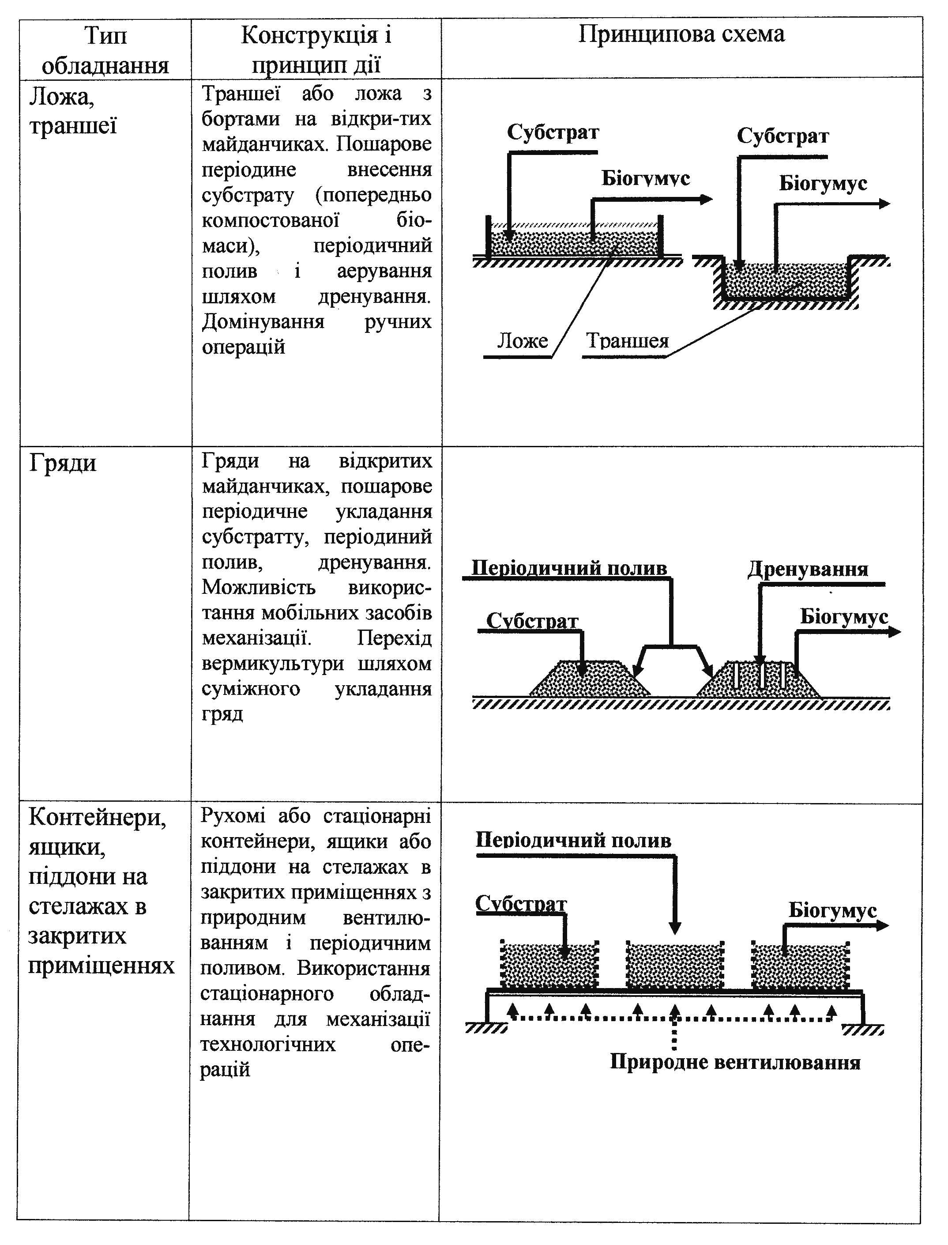
А | Ridges
B | The stock, trenches
C | Containers, pallets
D | Solid-phase reactors (cultivators)
Question 7.
50 | Joint methane fermentation of various biomasses call:
А | Cogeneration
B | Kofermentatsiya
C | trigeneration
D | Selective fermentation
Question 8.
50 | Which of these drugs has rodentydnu effect (similar to mouse used against rodents)?
А | Boverin
B | Baktorodentsyd
C | Tryhodermin
D | Haupsyn

Question 9.
50 | The photo shows:  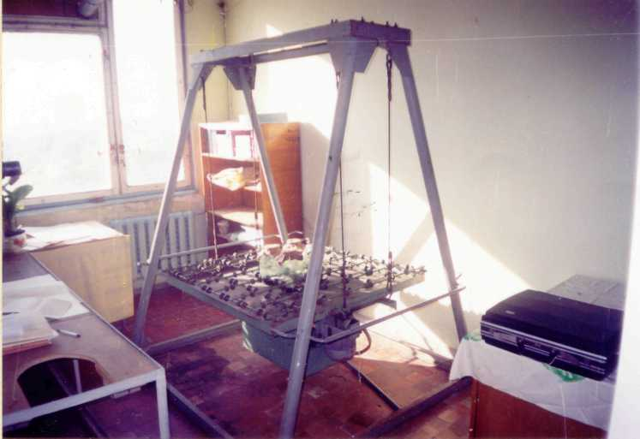
А | Rocking chair Suspended microbiological KPM
B | Kit for minivyrobnytstv mikrobiopreparativ BAC
C | Equipment for unified mass breeding entomoakaryfahiv ORE
D | Rocking chair Suspended microbiological KPM
Question 10.
50 | What is the storage temperature entomological drug Trichogramma?
А | +3 ±1 ° С
B | – 4 ±1 ° С
C | + 5 ±1 ° С
D | – 5 ±1 ° С
- FORMS OF CONTROLS
Rating of student from mastering of discipline is determined for 100 a ball scale. It consists of rating from educational work, at the evaluation of which 70 marks target, and rating from attestation (to examination) are 30 marks. Every semantic module is also estimated for 100 a ball scale.
On the rating of educational work by decision of the department can influence rating of additional work to  20 points and ranking penalty (with negative sign)  to 5 points.
Rating of student from educational work of R_{ew} is determined after a formula
0,7· (R⁽¹⁾_{М} + R⁽²⁾_{М} + R⁽³⁾_{М})
R_{НР} = -------------------------------------- + R_{ДР} - R_{ШТР},
3
where R¹_{M,} R²_{M,} R³_{M} - rating estimation of 1th 2th and 3th modules on a 100 ball scale. R_{AW} , R_{PW} - accordingly rating from additional work and rating of penalty area.
Students, who have received 60 or more points from educational work, cannot take the examination, and obtain test scores "Automatically". In this case the rating of student from discipline (R_{dis}) is equal to his rating of educational work.
R_{DIS} = R_{EW}

If a student wants to improve his ranking and improve the assessment of discipline, he must pass an exam. A exam is passed by students who has scored less than 60 points. For admission to exam a student must score at least 60 points from each module and in general - not less than 42 points from educational work.
Rating of student from attestation (R_{AT}) is determined on a 100-point scale.
Rating of student from discipline (R_{DIS})is calculated by the formula.
R_{DIS} = R_{EW} + 0,3 × R_{АТ}
10. Distribution Points that receive students. Evaluation of the student is in accordance with the provisions of "On the examinations and tests NUSEU in Ukraine" dated 02/20/2015. The protocol number 6 from the table. 1
national assessment | Assessment YEKTS | Визначення оцінки ЄКTС | Рейтинг студента,  бали
Excellent | А | Excellent - excellent performance with few errors | 90 − 100
Good | В | VERY GOOD - above average with some mistakes | 82 − 89
Good | С | GOOD - generally correct work with a number of blunders | 74 – 81
Satisfactorily | D | Satisfactory - not bad but many drawbacks | 64 − 73
Satisfactorily | Е | ENOUGH - performance meets the minimum criteria | 60 – 63
Unsatisfactorily | FX | Unsatisfactory - must work before get credit (positive evaluation) | 35 − 59
Unsatisfactorily | F | Poor - thorough and elaborate | 01 − 34
To determine the ranking of the student (listener) from mastering the discipline R_{ДИС} (100 points) received rating from certification (30 points) added to the ranking student (listener) for Academic R_{НР} (70 points):R _{ДИС} = R _{НР} + R _{АТ} .
12. Suggested Reading
General
- Біопалива (технології, машини і обладнання) / В.О. Дубровін, М.О. Корчемний, І.П. Масло, О. Шептицький, А. Рожковський, З. Пасторек, А. Гжибек, П. Євич, Т. Амон, В.В. Криворучко – К.: ЦТІ"Енергетика і електрифікація", 2004. – 256 с.
- Альтернативна енергетика: [навч. посібник для студ. вищ. навч. закл.] / М.Д. Мельничук, В.О. Дубровін, В.Г. Мироненко, І.П. Григорюк, В.М. Поліщук, Г.А. Голуб, В.С. Таргоня, С.В. Драгнєв, І.В. Свистунова, С.М. Кухарець, – К: «Аграр Медія Груп», 2011. – 612 с.
- Посібник. Технології та обладнання для використання поновлюваних джерел енергії в сільськогосподарському виробництві / [за ред. В.І. Кравчука, В.О.Дубровіна. – Дослідницьке: УкрНДІПВТ ім. Л.Погорілого, 2010. – 184 с.
- Біоенергія в Україні – розвиток сільських територій та можливості для окремих громад / [Дубровін В.О., Мельничук М.Д., Мельник Ю.Ф. та ін.]; за ред. В.О.Дубровіна, Анни Гжибек, В.М. Любарського. – Kaunas: Spausdino UAB "Tauraspolis", 2009. – 120 c.
- Біотехнологія: підручн. / [ В.Г. Герасименко, М.О. Герасименко, М.І. Цвіліховський та ін.]; за ред. В.Г. Герасименка. – К.: Інкос, 2006. – 647 с.
- Экологическая биотехнология; под ред. К.Ф.Форстера, Д.А.Дж. Вейза; пер. с англ. – Л.: Химия, 1990. – 383 с.
- Бекер М.Е. Биотехнология / М.Е. Бекер, Г.К. Лиепинь, Е.П. Райпулис. – М.: Агропроиздат, 1990. – 334 с.
- Герасименко В.Г. Биотехнология: учеб. пособ. / В.Г. Герасименко. – К.: Вища школа, 1989. – 343 с.
- Герасименко В.Г. Біотехнологічний словник / В.Г. Герасименко. – К.: Высш. школа, 1991. – 167 с.
Additional:
- Медведовський О.К., Іваненко П.І. Енергетичний аналіз інтенсивних технологій в сільськогосподарському виробництві. – К.: Урожай, 1998. – 205 с.
- Пастухов В.І. Енергетична оцінка механізованих технологій рослинництва. Методи і результати. – Харків: "Ранок-НТ" – 2003. – 100 с.
- Тараріко Ю.О. Енергетична оцінка систем землеробства і технологій вирощування сільськогосподарських культур. Методичні рекомендації. / Ю.О.Тараріко, О.Є.Несмашна, Л.Д.Глущенко. – К.:Нора – прінт, 2001. – 60 с.
- План дій по біомасі для України (проект). – К.:НТЦ „Біомаса”, 2008. – 43 с.
- Атлас енергетичного потенціалу відновлюваних джерел енергії, розроблений Інститутом електродинаміки НАН України за підтримки Державного комітету України з енергозбереження. – К.: Інститут електродинаміки НАН України, 2001.
- Малашенко Ю.Р., Хайер Ю., Бергер У., Романовская В.А., Мучник Ф.В. Биология метанообразующих и метаноокисляющих микроорганизмов. -К.: Наукова думка, 1993. - 256с.
- Використання біомаси на енергетичні потреби в сільському господарстві. Біогазові технології / [Таргоня В.С., Клименко В.П., Луценко М.М., Бабинець Т.Л.]; за ред. В.І. Кравчука. – Дослідницьке: УкрНДІПВТ ім. Л. Погорілого, 2009. – 72 с.
- Мельничук М.Д. Биотехнология растений / М.Д. Мельничук, Т.В. Новак, В.А. Кунах. – К.: Полиграфконсалтинг, 2003. – 520 с.
- Відтворення родючості ґрунтів у ґрунтозахисному землеробстві: наукова монографія; під ред. М.К. Шикули. – К.: ПФ “Оранта”, 1998. – 680 с.
- Агроекологія: навч. посібник / М.М. Городній, М.К. Шикула, І.М. Гудков та ін. – К.: Вища школа, 1993. – 416 с.
- Лер Р. Переработка и использование сельскохозяйственных отходов / Р. Лер. – М.: Колос, 1979.– 415 с.
- Виестур У.Є. Системы ферментации / У.Э. Виестур, A.M. Кузнецов, В.В. Савенков. – Рига: Зинатне, 1986. – 174 с.
- Баадер В. Биогаз: теория и практика / Баадер В., Доне Е., Бренндерфер М. ; пер. с нем. и предислов. М.И. Серебряного. – М.: Колос, 1982. – 148 с.

