
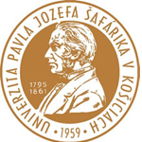


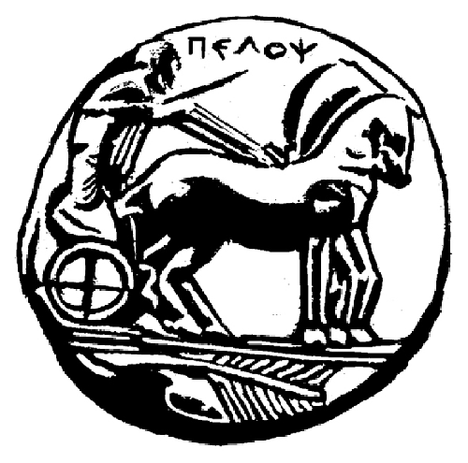


MINISTRY OF EDUCATION AND SCIENCE OF UKRAINE
NATIONAL UNIVERSITY OF LIVE AND ENVIRONMENTAL SCIENCES OF UKRAINE
H.S. SKOVORODA INSTITUTE OF PHILOSOPHY OF NATIONAL ACADEMY OF SCIENCES OF UKRAINE
UNIVERSITY OF PELOPONNESE
VILNIUS UNIVERSITY

International Scientific Conference
«HUMAN BEING, SOCIETY, AND STATE IN PHILOSOPHICAL DISCOURSE: HISTORY AND MODERNITY»
Devoted to the 60th anniversary of the Department of Philosophy
National University of Life and Environmental Sciences of Ukraine

May 18-19, 2017
Kyiv, Ukraine

The conference aims to bring attention to current philosophical issues of the modern society and to investigate trends, features and prospects of contemporary science and education.
Location: Faculty of Humanities and Pedagogy, education building № 1, auditorium 69, address: 19 General Rodymtsev st., Kiev, Ukraine, 03041.
We are pleased to invite researchers, graduate students, PhD and master students, professors and faculty staff of universities.
Abstracts will be published in the Conference proceedings.
Scientific articles (8 - 12 pages) will be published in the Scientific Journal of NULES of Ukraine. Series: Liberal Arts. Certificate of registration КV № 20018-9818 17.05.2013. The Journal is indexed in the following international scientometric databases: INDEX COPERNICUS; MIAR; ResearchBib; AGRIS; Google Scholar. ISSN 2518-7317 (Online), ISSN 2518-1076 (Print). Impact factor: http://journals.nubip.edu.ua/index.php/Gumanitarni .
Languages: Ukrainian, Russian, English, Slovak, Polish.

Conference tracks:
Section 1. Philosophy of Education in the 21st century: achievements and perspectives
Section 2. Actual issues of Philosophy of Science: epistemological and methodological approach
Section 3. Philosophical Anthropology and Social Philosophy: the Third Millennium dimensions
Section 4. Humanitarian discourse in historical and philosophical retrospect (devoted to the 295th
anniversary of Hryhoriy Skovoroda and 200th anniversary of Mykola Kostomarov)
Section 5. The innovative character of modern science as a response to modern challenges
Section 6. Psychological, pedagogical and institutional preconditions for introduction of European standards into the Higher education of Ukraine
Section 7. Historical, cultural and philosophical problems of national state development in Ukraine (devoted to the 100th anniversary of the establishment of the Ukrainian People’s Republic)
Section 8. Actual issues of Religious Studies in Ukraine: challenges and perspectives
Section 9. Cultural and historical potential of humanitarian sciences: modern challenges
The thematic areas are not limited by the abovementioned!

Schedule of work
Thursday, 18 May |  |  |  | Friday, 19 May
Conference registration  9 -10 a.m.  Opening of the conference  10 – 10.30 a.m.  Plenary meeting  10.30 a.m. – 13.00 p.m.  Lunch  13.00 – 14.30 p.m.  Concurrent sessions  14.30 – 16.30 p.m. | 10 a.m. –12 p.m.  12 – 13 p.m. |  | – Panel discussion «Problems of personality’s actualization in the social cultural environment of the contemporary Ukraine» with the participation of graduates from PhD school of the Department of Philosophy of NULES of Ukraine  Summarizing. Adoption of the resolution
 | 13 -14 p.m. |  | Conference closing. Departure of participants

Registration

To take part at the conference please send your application, abstract (example is attached) and copy of registration fee payment (photo or scan) to the organization committee via e-mail philosophy_konf_nubip@ukr.net (with note «Conference») before May 1, 2017
Name of the file should include name of the author – for Application (e.g., Vitruk_application.doc), for Abstract (e.g., Vitruk_abstract.doc)
Application_example

Application
To participate at the International Scientific Conference «HUMAN BEING, SOCIETY, AND STATE IN PHILOSOPHICAL DISCOURSE: HISTORY AND MODERNITY»
Name, family name
Institution
Position
Academic degree
Academic rank
Paper title
Section
Form of participation | Personal attendance/Publication only
Contacts:
Е-mail
Phone number

REQUIREMENTS FOR ABSTRACTS
- Abstracts up to 3 pages;
- Margins: left 25 mm, top, right, bottom 20 mm;
- Font – Times New Roman, 14 pt; line spacing 1,5; style – Normal;
- Line 1 (left) - information about the author: surname, name and patronymic (fully), academic degree, rank, position, educational institution. Line 2 – empty, 14 pt. Line 3 – paper title (center justification, bold). Line 4 - empty, 14 pt.
- References should be listed after the main text according to standard bibliographic description;
- For in-text citations: numbers in squire brackets;
- The pages are not numbered;
- The materials are presented in a text editor Microsoft Word for Windows with the extension *.doc, or *.docx
Note: the Organizing Committee of the Conference sends a message about the receipt of your letter within four days. If you do not receive the message, send the abstract once again or call to the Organizing Committee by phone to the Secretary of the Conference

Example for Abstracts
УДК 37.013. Kultenko Valentyna Pavlivna,
PhD, Associate Professor,
National University of Life and Environmental Sciences of Ukraine
(Kiev, Ukraine)

PHILOSOPHY OF EDUCATION WITHIN THE SYSTEM OF MODERN PHILOSOPHICAL STUDIES
With the change of the economic realities, an urgent need for…[…text…]
LITERATURE
1…
N.B. Editorial Board reserves the right to edit or reject materials that violate the requirements!

Organizational fee

Organization fee:
150,00 UAH (printed materials + certificate of participation);
100,00 UAH (printed materials + certificate of participation – for students)
Registration fee - bank details:
Bank: PrivatBank
Account: 29244825509100 ОКПО: 14360570
МФО: 305299
Full name: Vasylkivskyi Illia Pavlovych
Purpose of payment: replenishment of 5168757313045298
Doctors of Sciences participate at the Conference for free. All travel costs carried out by the participant of the Conference at their own expense or at the expense of his/her institution.
The Organizing Committee will assist in finding accommodation in Kyiv hotels on individual request. Accommodation, food, travel and visa costs are covered by participants.

ORGANIZATIONAL COMMITTEE
National University of Life and Environmental Sciences of Ukraine

Kiev, Heroyiv Oborony st, 15, educational building № 3, room 20, 21
Phones: (044) 527-81-50
+380-97-683-57-35 – Inna Mykolaivna Savytska;
+380-67-950-59-28 – Taras Vitaliyovych Gorbatyuk
Е-mail: philosophy_konf_nubip@ukr.net

