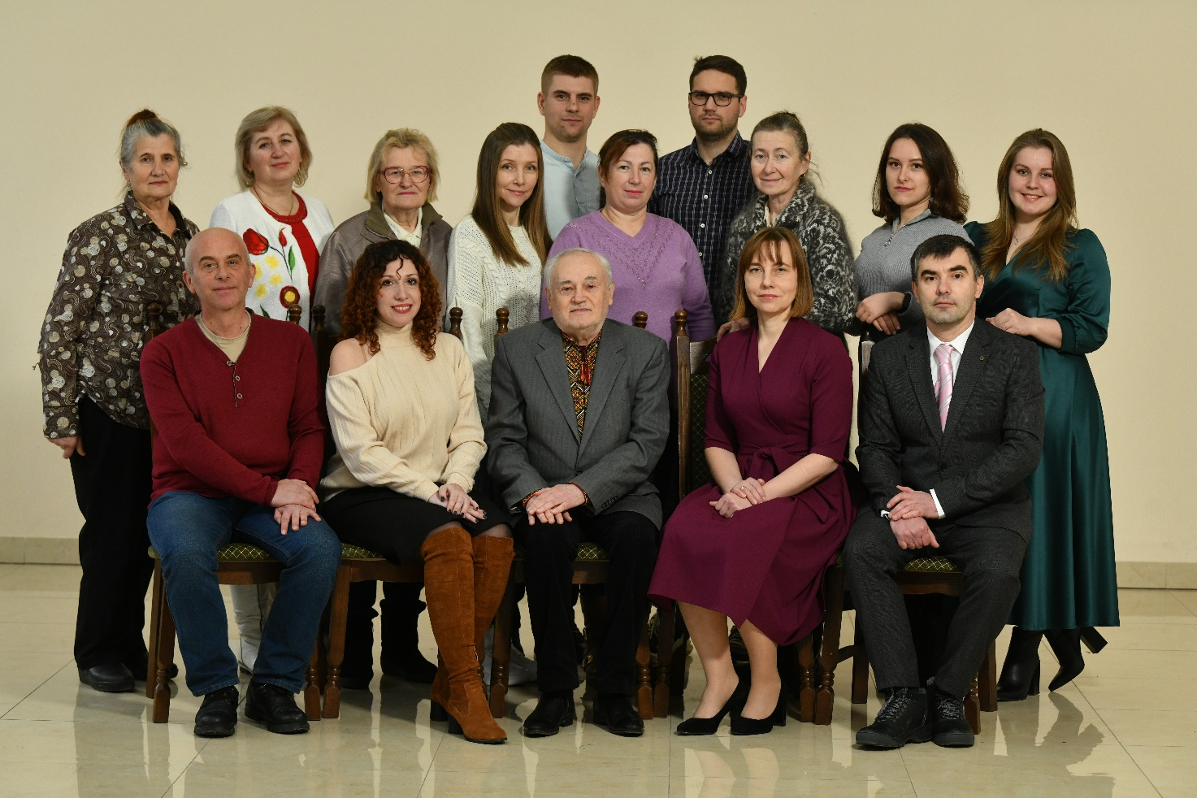
The staff of the department today (from left to right)
first row: assoc. prof. L. M. Abarbarchuk, assoc. prof. O.O. Kravchenko, head of department, prof. V. A. Kopilevich, assoc. prof. T. I. Uschapivska, assoc. prof. R. V. Lavryk;

second row: senior lab K. G. Kozak, assoc. prof. V. M. Galimova,
eng. 1 cat. N.Yu. Zinich, senior lab. O.V. Danylchenko, head of education lab S. V. Romanchuk, assoc. prof. T. K. Panchuk, PhD student E.A. Zalenska,
PhD student A.K. Gats

third row: PhD student V.V. Chobotar, PhD student M.O. Grechaniuk

(absent from the photo: Prof. V.I. Maksin, assoc. prof. N.M. Prokopchuk, assoc. prof. L.V. Voytenko, PhD student K.A. Nesterova)

