Vladyslav Danyliuk STUDENT ID:2513818

The Macroeconomic Consequences of the Coronavirus Pandemic in the UK

Report

- Economic impact of the pandemic 2

- Impact on Unemployment 2-4

- Impact on Inflation 5-6

- Impact on GDP 7-9

- Monetary Policy 10-12

- Fiscal Policy 13-15

- Supply Side Policy 16-17

- Evaluation 18-19

- Conclusion 19

Bibliography 20-21
Economics Impact of the pandemic
The government of the UK announced a lockdown on 23 of March. Also, World Health organization qualified coronavirus as pandemic. Basically, pandemic is an epidemic of infection that has spread all over the world and it can affect on number of population. Lockdown had huge negative impact on macroeconomic concepts and objectives, especially at the start of pandemic. Generally, the key macro objectives are stable low inflation, sustainable growth, high employment and balance between income and outcome. All those objectives have a huge impact on economic in every country.
Impact on Unemployment
Businesses such as restaurants, cafes, shops, airlines, entertainment companies and a lot of others were closed because of lockdown. A lot of owners decided that they can’t afford to pay salaries to their workers, so they closed their businesses. So workers didn’t received any salary and they couldn’t buy even food. Also, small business such as restaurants, cafes, pubs were suffering because of lockdown. However, the government tried to help small businesses and provided better conditions to them and payed some money to workers that lost their jobs.

Source: https://www.oecd.org/economy/united-kingdom-economic-snapshot/(2020)
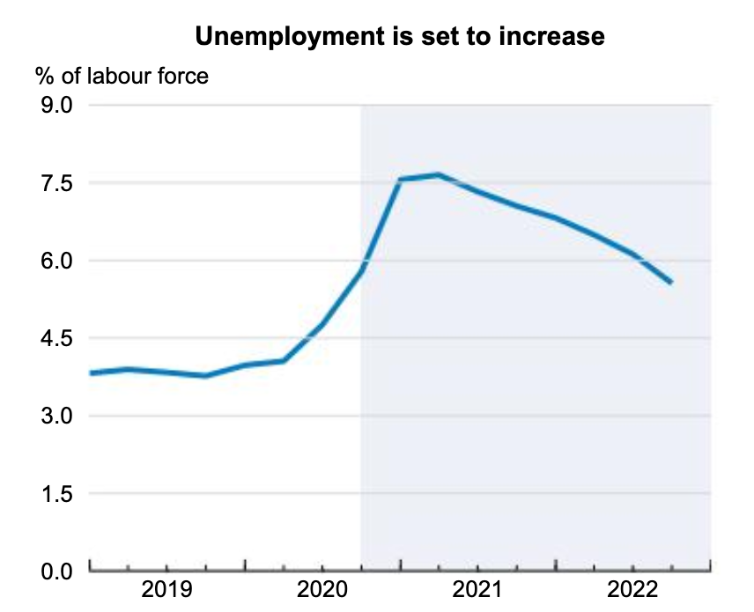

Judging by this graph, we can consider that the unemployment rate has increased since 2020. In 2019, the rate was approximately around 4%, however in 2020 it increased up to peak, which was more than 7,5%.It happened because small business was suffering and owners just reduced working places, so a lot of people lost their jobs. Also, we can see that analysts predict that unemployment rate will slightly decrease during next two years.

Source: https://www.bbc.com/news/business-5266059120
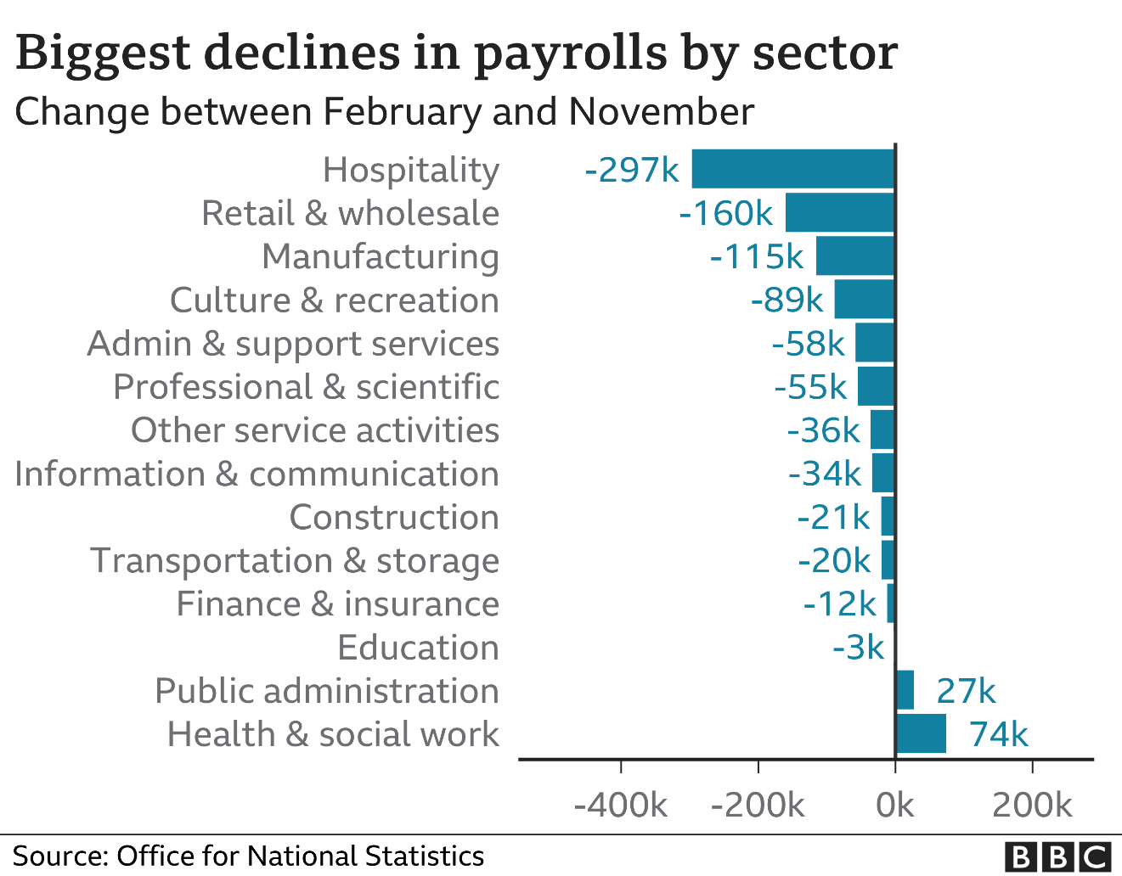
This chart shows biggest unemployment fall by sector. We can consider that the hospitality lost the most of workers, around 297 thousands because a lot of restaurants ,pubs ,cafes were clothed because of lockdown and owners couldn’t afford to pay salaries to workers so they lost their jobs. Also, we can see that sectors like manufacturing, retail, culture and support services lost a lot of workers too. At the same time, we can consider that public administration and health work didn’t lose workers. Moreover, 27 thousand new workers started to work in public administration and 74 thousand in health and social work. Such increasing of workers in these sectors can be due to the fact that such jobs became more demanded during pandemic and people feel their duty to safe others life or to control a country during such a hard time.

Basically, unemployment has a negative impact on economy. Firstly, the householders will have less income because of high unemployment. It means that workers won’t pay any taxes to the government, so they won’t have money to develop a country. Secondly, the demand of some services and products will increase because people will prefer to buy or use cheaper alternatives. In the one hand, businesses who own such alternatives will have benefits from unemployment, however the purchasing power of customers will decrease and companies will not earn as much money as possible.

Judging by all factors, we can consider that there is a cyclical unemployment. Basically, such type of unemployment exists when people lose their jobs because of decreasing in aggregate demand, which is particularly connected with labour market. Nowadays, we can see that individuals are loosing jobs because interest rate is decreasing, so aggregate demand shifts to the left.
Source: https://www.intelligenteconomist.com/cyclical-unemployment/(2020)

This graph shows the fall in aggregate supply which means that country lose output. Also, cyclical unemployment can cause a rise in natural rate of unemployment. For example, if young people are out of work for a long time, it will be hard for them to find a new job because of lack of work experience and motivation.

Government reacted immediately on this problem and furlough scheme and financial support for individuals and householders. Employees are receiving 80% of their current salary, so they can stay at home without work. They can maximum receive £2,500. Also, government gives different grants and financial support to businesses. They can receive up to £3,000 per month. In addition, £1,1 billion is being given to support businesses by October 2020. Also, government provided mortgage holidays up to six months. Such reactions helped to stabilize the level of unemployment, however, it didn’t help to reduce unemployment because a lot of businesses are being closed nowadays because of lockdown.

Impact on Inflation
Basically, keeping stability of inflation is one of the main key objectives. Inflation means a general rise in the price level, so the value of money decreases. Inflation has positive and negative effects on economy. Firstly, it causes a falling in real incomes because workers will earn less money because of cutting wages. Secondly, inflation can cause an ‘inflation noise’, when customers are not sure what are causes of price rising: new technologies or inflation. However, inflation cause reducing of unemployment because people would need to work more to earn some money, so the householders and companies will provide a lot of new working places.

Source: https://www.bbc.com/news/business-55729988(2021)
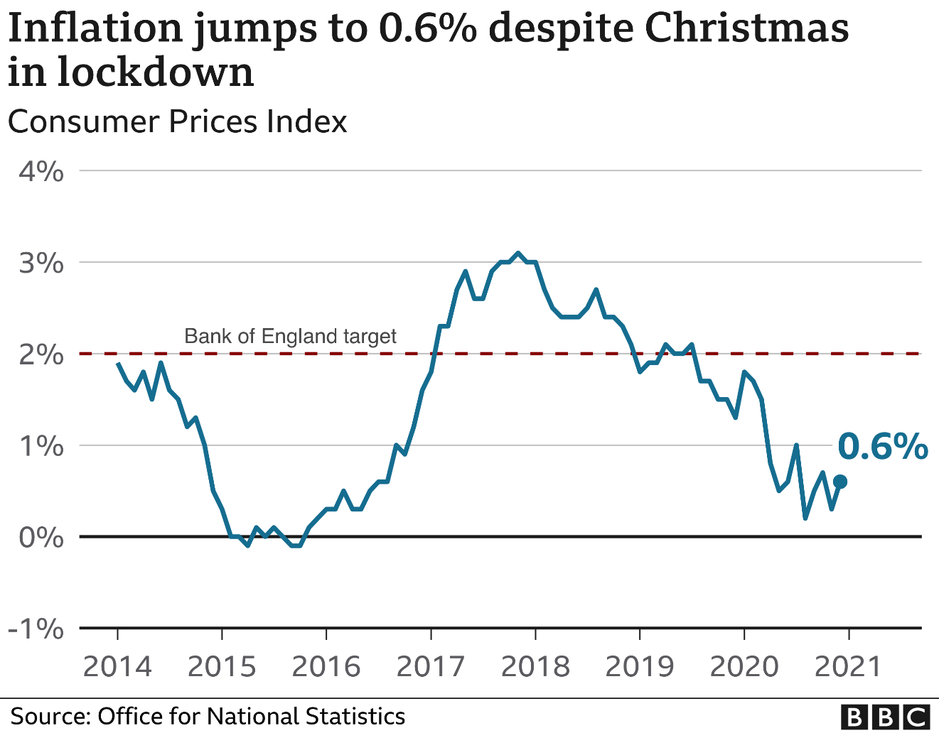

Judging by this graph, we can consider that the target of inflation in the UK is 2%. We can see that the level of inflation was 0% in 2015. However, after announcing ‘Brexit’ the level of inflation started to increase and reached a pick of 3% in 2017. Also, CPI slightly decreased at the end of 2019 and started to fluctuate during a lockdown. The last available statistics reached 0.6% during Christmas lockdown.

Source: https://www.bbc.com/news/business-55729988(2021)
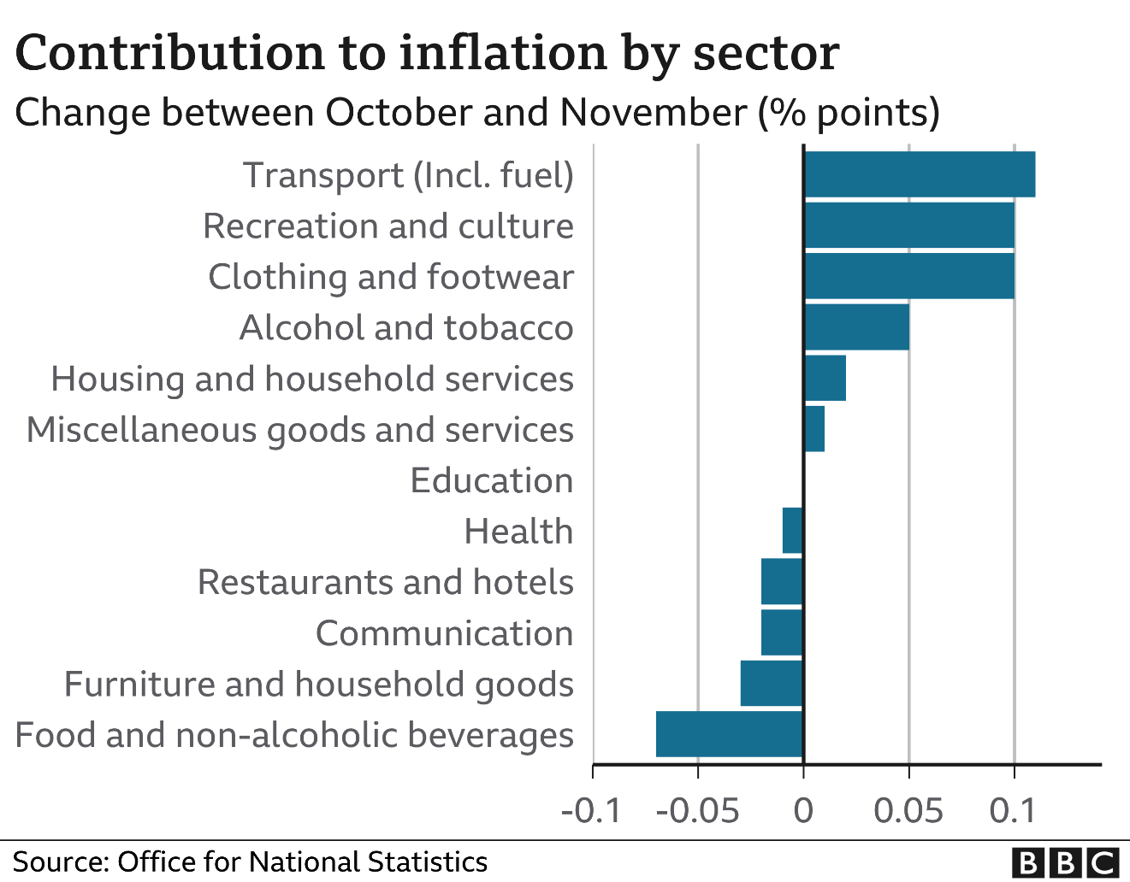

This chart shows a contribution to inflation by sector. We can consider that the highest level of inflation is in transport, recreation/culture, clothing/footwear and alcohol/ tobacco sectors. At the same time, the education sector remains steady. However, we can see that the lowest level of inflation is in food and non-alcoholic beverages sector. Also, furniture/households goods, communications and restaurants/hotels have low inflation

Judging by all these factors, we can consider that there is a demand-pull inflation. Basically, it occurs when the demand increases for goods. It can create a demand-supply gap with less flexible supply and higher demand. When lockdown started, the demand for medications, face masks, gloves, hand sanitizers and toilet paper dramatically increased, so prices rised too.
Source: https://www.economicshelp.org/blog/27613/inflation/demand-pull-inflation/(20190

Impact on GDP
Gross domestic product is one of main key objectives in macroeconomics. It shows how much has country produced and the value of economic activity. So if the level of GDP is high, it means that country produced a lot of goods on import or export and has strong and stable economy. However, it has some problems. First of all, the rise in real output can easily cause the rise in population because there will be more worker that will produce more goods for a country. Also, GDP doesn’t show real standards of living. It means that country that has huge GDP level can have bad level of living standards. For example, GDP of India was 2,868.93 billion dollars in 2019, which was 5 ranking position after the USA, China, Japan and Germany. However, India takes 131 position in ranking by Human Development Index according to the United Nation Development Programme. And last but not least, GDP measure does not account informal economy such as home renovations, car repairs, cash in hands etc. GDP is measured by taking the amount of all goods and services created, multiplying them by their prices and summing the total. Basically, there are three methods of measuring the GDP: the value added, the income method and the expenditures method.

Source: https://analyzingalpha.com/boom-bust-cycles(2020)

The graph below shows an economic cycle. Basically, when the level of GDP reaches peak, it means that country produces the maximum output. So after that the level of GDP will fall, so economy needs some time to recover and start to grow again. Nowadays, GDP level is decreasing via pandemic. Economy will be recovering quite slow, so the rise of GDP won’t be in short term period. However, government provided vaccination which can really help people to start working not in home, so more people will have jobs because pandemic will be over. It means that country will produce more output and GDP can slightly increase.

Source: https://commonslibrary.parliament.uk/research-briefings/cbp-8866/(2021)
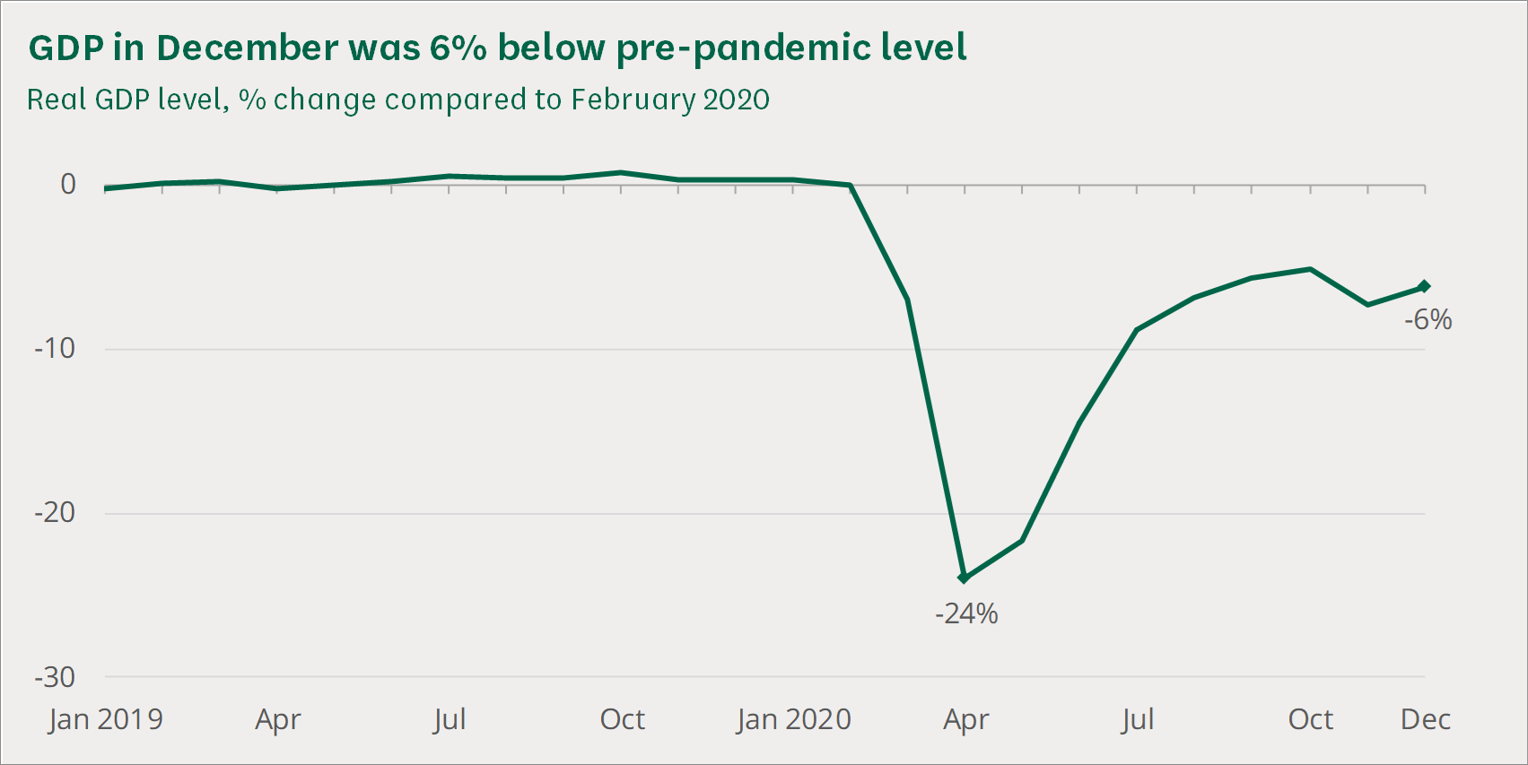

This graph shows the level of GDP from January 2019 to December 2020. The level of GDP was stable before March 2020. It was remaining approximately 0-1% of growth. However, after lockdown it dramatically decreased and reached it minimum point in April 2020 (-24%) because all restaurants, shops, airports etc. were closed and country didn’t produce as much as it produced before coronavirus. After introduction of adaptive quarantine, the level of GDP increased to -6% in December 2020.

After lockdown, the Bank of England decreased interest rate which stimulated slight GDP growth. Householders started to invest money into economy and a lot of new appeared. Also, some companies were developed and started producing more income for economy, for example delivery services have dramatically developed since lockdown started because more people use them. After that, in June, government made less restrictions and allowed air companies, shops, public transport etc. to work. All these responds helped GDP to growth, however, the level of GDP still negative and last available data shows -6% in December 2020.

Source: https://www.ons.gov.uk/economy/grossdomesticproductgdp/articles/coronavirusandtheimpactonoutputintheukeconomy/march2020(2020)
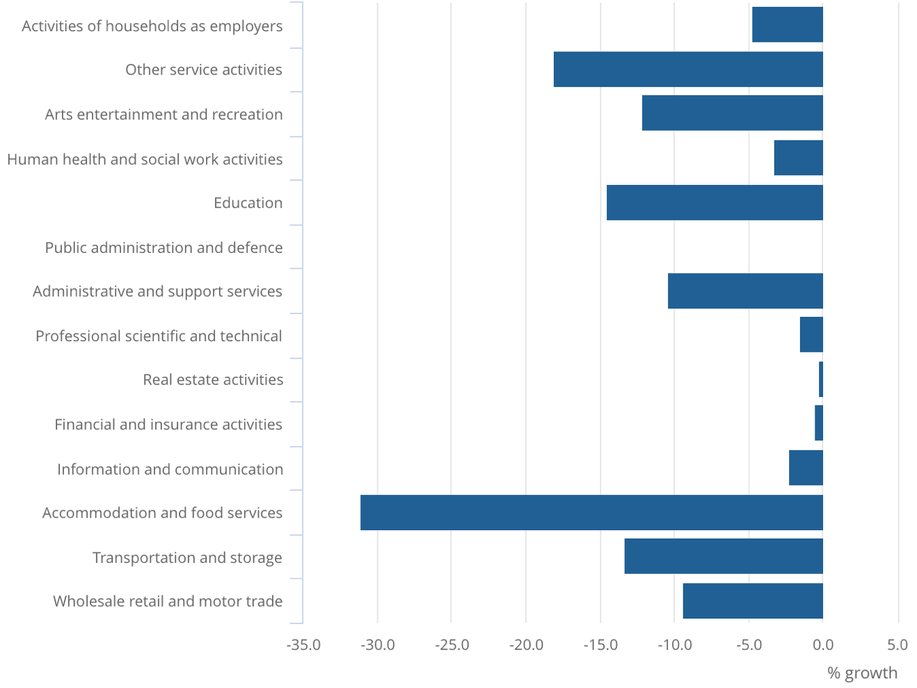
Judging by this graph, we can consider that the level of GDP decreased almost in all sectors. The biggest fall is in accommodation/food services and education sectors because after lockdown all restaurants, hotels, universities and schools were closed, so they couldn’t produce anything. All schools started to work on online platforms such as Zoom, Skype, Discord, Teams etc. So they reduce price for education for students. Restaurants started to deliver food but they couldn’t make as much money as they had been making before lockdown. However, there was a slight fall in information/communication, financial/insurance activities and real estate activities sectors( up to -1%). Also, the GDP of public administration and support services didn’t even decreased because such sectors started to work online before restrictions, so they almost didn’t feel effects of lockdown.

Monetary Policy

Monetary policy is a demand side policy that is used by government to control inflation. This policy consists of the management of interest rate and money supply. The Bank of England is currently responsible for keeping the level of inflation at 2%/+-1% that is measured by consumer price index. Basically, there are two types of monetary policy. First one is expansionary policy, when Bank of England reduces interest rates to make a borrowing of money more attractive for investors and consumers. Also, the decreasing interest rate makes saving accounts and government bonds less attractive, so investors will take risk assets and aggregate demand will rise. For example, during the 2008 financial crisis, the Bank of England reduced interest rates to near zero and conducted stimulus spending programs which stopped the inflation growth.

Source: https://www.economicshelp.org/blog/4886/monetary-policy/expansionary-monetary-policy/(2017)

However, there is another type of monetary policy- contractionary policy, when Bank of England increases interest rates. This policy can be used when the economy is growing too fast and demand-pull inflationary pressures are strong. This policy reduces the amount of credit and money that bank can lend and basically, it decreases the money supply by making loans more expensive. So, aggregate demand shifts to the left. For example, in the 1970s, inflation grew to 10%, so the Fed raised interest rate to 13% by July 1974 and increased to a peak of 20% in 1981. Such decision was highly criticized by society because a lot of people think that a contractionary policy caused the ‘Great Depression’. However, this policy was quite successful and stopped inflation.

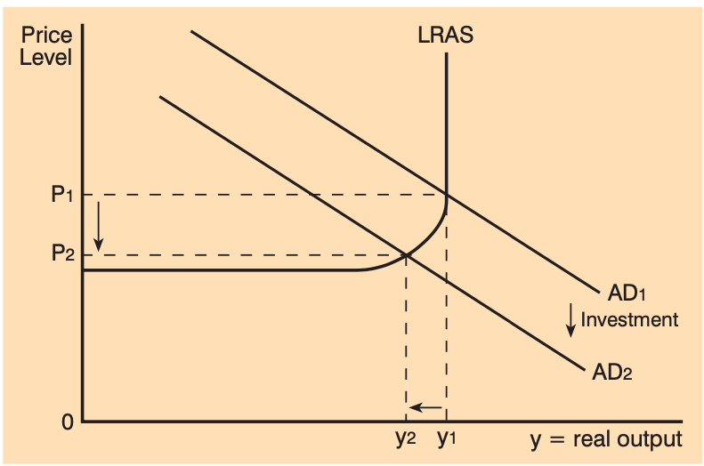

During lockdown, the Bank of England chose to implement expansionary monetary policy. It decreased interest rates to 0.1%, which encouraged householders to take more loans. Also, other banks were supported by the Bank of England, so they almost didn’t lose a lot of money. At the same time, bank helped businesses to pay their staff and suppliers by offering them money for their corporate debt. Also, the government exempts stamp duty which is a tax relief for people who want to buy houses offering flexible mortgage home loans of up to 95% to keep the macro economy running Overall, these actions helped to stabilize the level of inflation, however the level of inflation now is 0.6%,according to BBC, which is not corresponds to the target of Bank of England which is 2%.

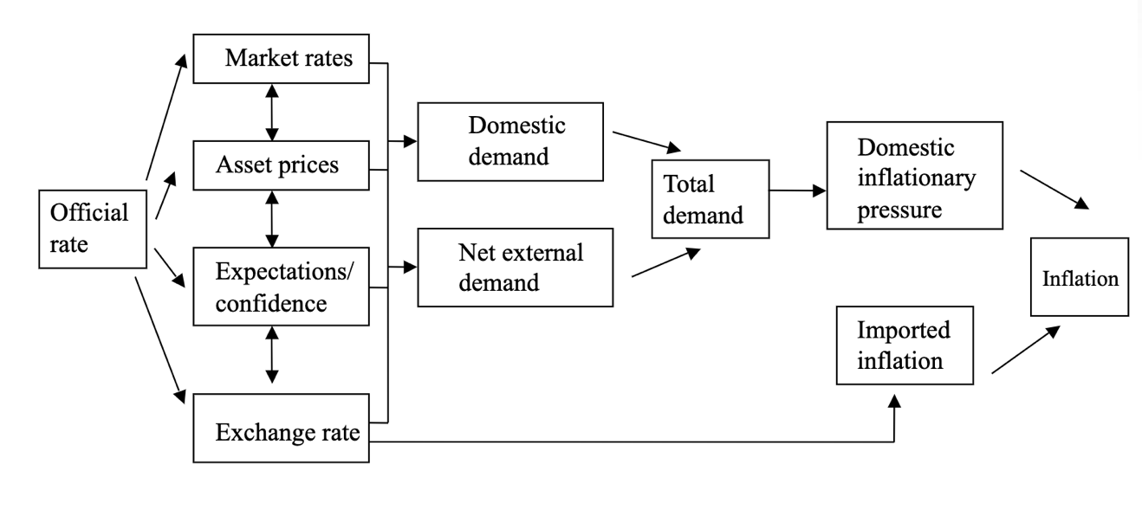
This graph shows the monetary transmission mechanism which basically shows how monetary policy will affect inflation. Basically, the changing interest rate has huge impact on market rates because all bonds will increase or decrease, so householders will change the amount of their investment into country depending on the interest rate. Also, monetary policy effects on asset prices. For example, if analytics think that the economy will have a benefit by cutting interest rate, the asset price can dramatically increase. So a person who has such assets can feel richer and person’s consumption will increase or he or she can even take a credit using their assets as collateral. So if policy fails, a lot of people will lose huge amount of money and assets which can cause a financial crisis. It is also connected to confidence in economy. If economy is stable, more investors will invest money and economy will growth. In addition, changes in the official rate can cause changes in exchange rate. When country increases interest rate, investing in that country becomes less attractive. Moreover, changes in exchanging rate can affect imports and exports. For example, a fall in the value of currency can has a positive impact on export, at the same time a rise can result in a positive way on imports. Basically, all these areas have a huge impact on aggregate demand. Depending on changes interest rate, it can shift to the left or to the right.

Overall, monetary policy cannot solve all economic problems. Basically, the main instrument is interest rate. Government uses it to attract householders to borrow money in banks and invest this money in economy. Big investments stimulate economy to growth and reduce inflation. However, if economy isn’t stable, big companies won’t invest money in it. Also, consumer confidence will fall and they would rather save money and spend less. As a result, aggregate demand will shift to the left.

Lastly, monetary policy can be affective after pandemic if interest rate remains low and consumer/householders confidence will increase. However, low interest rate can lead to fall in currency. Also, the balance payment can become negative, so aggregate demand can be reduced.

Fiscal Policy
Fiscal policy is another demand side policy that is used to control the level of inflation and employment. The main instruments of this policy are taxation and cutting or increasing government spending. Basically, there are two types of taxation: direct and indirect tax. Direct tax is when individuals pay directly to the government. For example, personal property tax, real property tax and corporate tax. Indirect tax is when individuals pay for services ,for example VAT, excise tax and service tax.

Expansionary fiscal policy is when government increases government spending and cuts taxes. Basically, such type of policy gives more money for individuals/householders and increasing purchasing power, so the level of inflation will decrease. This policy can also reduce unemployment by hiring new government workers or contracting public works. Expansionary fiscal policy leads to a rise in aggregate demand, however, country can face a deficit because government spending will be increased. A good example of successful implementation expansionary fiscal policy was in 2009. The Obama administration cut taxes and increased government spending. It called the Economic Stimulus Act. This act reduced inflation and unemployment rate after financial crisis in 2008.

Source: https://www.economicshelp.org/blog/4886/monetary-policy/expansionary-monetary-policy/(2017)

Contractionary fiscal policy is when government cuts government spending and rise taxes. Basically it uses to slow economy growth because high economic growth can cause negative consequences. First of all, it creates inflation because value of money will be decreasing. Also, high economic growth is unstable and always leads to recession because of economic cycle. Lastly, high employment can lead to high unemployment. It sounds paradoxically but employers won’t find workers for new working places. For example, Franklin Roosevelt used contractionary fiscal policy after the Great Depression to cut the debt. If government uses this policy, the aggregate demand will shift to the left.

Basically, UK government chose to use expansionary fiscal policy. The total government spending is £938 billion and £12 billion of this budget is assigned to help public services, individuals and businesses. The government didn’t increase or decrease taxation because of national debt which is 2 trillion pound. This debt was 84,5% of GDP in 2019. Nowadays, because of lockdown, this debt will be slightly increasing. However, such responds didn’t helped economy because inflation hasn’t reached a target, the level of GDP is still negative and the level of unemployment is increasing.

Source: https://www.researchgate.net/figure/The-structure-of-fiscal-policy-transmission-mechanism-Source-Virchenko-2011_fig3_283974499(2011)
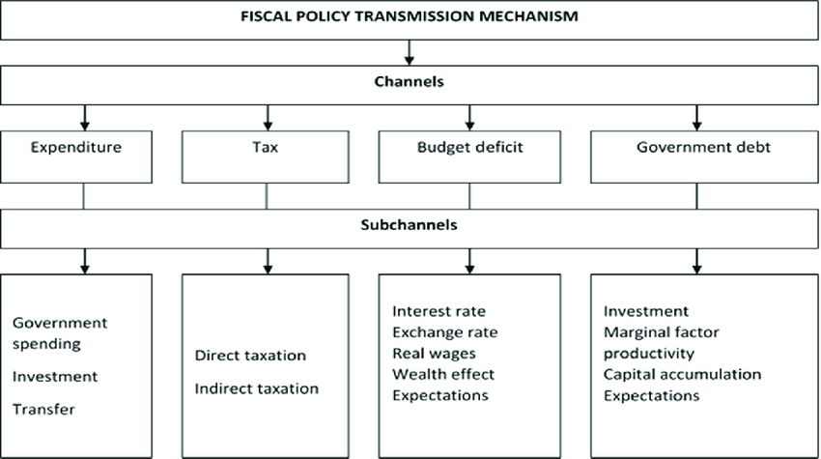

This graph shows the fiscal policy transmission mechanism. Basically, when government implements this policy, it will affect four main channels: government debt, tax, budget deficit and expenditure. It happens because government spends more money, if it is expansionary policy, and cut taxation. Nowadays, a lot of countries have a national debt, so they can’t afford to increase government spending and cut taxation. As I said before, the UK has huge debt, so government can’t use fiscal policy in full, so they increased government spending during a lockdown, which can lead to budget deficit and inflation in the future. However, the British currency remain quite stable and shows good level compares to dollar or euro. But, as we all know, after economic growth there is a huge recession, so the government needs to be ready for it. Also, fiscal policy can cause a crowding effect. This effects leads to increasing interest rate, which means that companies and individuals won’t borrow a lot of money and won’t invest them into country. That’s why country won’t have a lot of income and it can cause huge inflation and unemployment rate.

Currently, the expansionary fiscal policy isn’t effective. Government can’t cut taxation because of national debt, so it isn’t such effective as could be. Also, judging by statistics, fiscal policy doesn’t reduce unemployment because a lot of householders lost their businesses and economy isn’t producing new working places because it is in recession. Also, companies aren’t confident in British economy, so they don’t invest money and government doesn’t have income. As a result, fiscal policy doesn’t make a multiplier effect, so a lot of people keep losing their jobs nowadays.

However, in future, government spending can have a good impact and increase employment. When lockdown finishes, the economy will be growing quite fast and there will be a lot of new working places and businesses, so aggregate demand will shift to the right. However, there is an opportunity cost of spending huge amount of money in social services such as NHS, police department etc. especially after COVID-19 pandemic.

Supply Side Policy
Supply side policy is commonly used by government to supply more goods and output. Basically, aggregate demand and the level of GDP will increase in long term. Basically, there are two types of supply side policy: free market policy and interventionist supply side policy.

Free-market supply side policy is used to increase competitiveness on the market. The government uses privatization, lower income tax rates and deregulation to boost economic growth and reduce power of trade unions. However, this type of policy can be effective only in long term. For example, after collapse of the Soviet Union, Russia opened a free market and started huge privatization. There was a huge inflation in first five years, because trade unions had huge power and there were a lot of monopolies, so they dramatically increased prices and the value of money decreased. However, Russia integrated in world’s economy by 2000s.

Interventionist supply side policy is being used by government to overcome market failures by increasing government spending on education, transport, healthcare, infrastructure etc. However, this policy isn’t perfect. First of all, supply side policy can’t solve a fundamental problem during a recession, which is lack of aggregate demand. Also, interventionist supply-side policy needs time to become effective. For example, a lot of countries has been implementing this policy over the past 25 years before financial crisis in 2008. However, only now, this policy started to be effective. In addition, Chinese level of education was bad in last century, however, over the past 30 years it has grown and ,nowadays, a lot of students are coming to China to study there.
Source: https://www.economicshelp.org/macroeconomics/economic-growth/supply-side-policies/(2019)
This graph shows that aggregate supply shifts to right, when supply side policy is implemented. Basically, this policy has a lot of advantages. First of all, shifting AS to right can cause a lower price level. It means that the level of inflation will be reduced. Secondly, the level of unemployment can be reduced in long term because of good education and better job information. Also, a free market supply policy can trade a Balance of Payments by stimulating the level of competitiveness, which can increase exporting. Last but not least, increasing LRAS can cause a significant economic growth.
Currently, government uses interventionist supply side policy and spends a lot of money on healthcare, because of COVID-19. Nowadays, there are 4,25 million who had coronavirus and 125 thousand who has died because of it. That’s why, the government started to invest a lot of money in NHS. During this pandemic, country has built a lot of new hospitals, bought a lot of mechanical ventilators for lungs and hired more doctors. Also, the UK bought vaccines and it is one of the best countries in the world by the number of people, who were vaccinated. All these actions helped to stabilize the number of disease cases and vaccination helps to reduce the number of deaths because of coronavirus.

Overall, the supply side policy is good for aggregate supply and very useful for country. However, this policy needs time to become effective, so it has a time lag. Also, this policy is quite expensive for government because it needs to spend a lot money on education and training problems which will involve labour which is expensive. Moreover, this policy can be ineffective if government chooses wrong vector of development. However, in long term, supply side policy can show great results and aggregate supply will shift to the right. Nowadays, the government spends a lot of money on healthcare and online education, so, in future, the healthcare system in the UK will be one of the best in the world, so people will live longer and produce more goods, which is good for economy. Also, the education will be completely changed and there will be a lot of online universities, so people can study from different part of the world.

Evaluation

Basically, there are conflicts in macro objectives. First one is- Economic growth and inflation. If there is dramatic economic growth, it means that inflationary pressure will increase. It happens because when economy is growing too fast, it is hard to employ new workers, so it can cause inflation in wages. In addition, higher wages cause higher prices on consumer goods. For example, during the Lawson boom, British economy was dramatically increasing (4-5% a year). However, after that, there was a recession in 1991 and the government increased interest rates to control it.

Source: https://www.economicshelp.org/blog/419/economics/conflicts-between-policy-objectives/#:~:text=One%20macro%2Deconomic%20conflict%20can,conflict%20between%20unemployment%20and%20inflation).&text=When%20the%20economy%20is%20growing,higher%20wages%20cause%20higher%20prices.(2019)

This graph shows that AD increases when economy grows too fast, however there is also an increase in inflation rate. Also, economic growth can conflict with balance of payments. When growth is led by consumer spending, it can influence on current account and cause deficit in it because when consumer spending increases, there will be a rise in import spending. In addition, the economic growth also conflicts with environment. When GDP increases, it will affect environment because a lot of factories will be working to produce more goods and smoke will pollute air. However, nowadays, there are many different technologies that can save our planet. For example, solar stations, electric cars and others. Also, government can save environment by increasing taxation. Lastly, when unemployment falls, it creates more working places. At the same time, it creates pressure on wages, so inflation increases.

Source: https://www.economicshelp.org/blog/419/economics/conflicts-between-policy-objectives/#:~:text=One%20macro%2Deconomic%20conflict%20can,conflict%20between%20unemployment%20and%20inflation).&text=When%20the%20economy%20is%20growing,higher%20wages%20cause%20higher%20prices.(2019)

The Phillips curve shows a trade off between inflation and unemployment. Judging by this graph, we can consider the lower unemployment rate, the higher inflation rate. However, if the economic growth is stable, the level of unemployment will be low. Also, government can reduce structural unemployment without causing inflation by implementing supply side policy.

Conclusion

In conclusion, Covid-19 has dramatically affected British economy because a lot of businesses were closed, so government didn’t receive as much income as it received before a pandemic. At the same time, the government implemented monetary, fiscal and supply side policies to stabilize the level of macro objectives. However, these policies will show great results in long term, after lockdown will be finished.

Bibliography

Graph 1:OECD(2020); ‘Economic Forecast Summary’; [Online]; Available at:https://www.oecd.org/economy/united-kingdom-economic-snapshot/ [Last accessed 15/02/2021]

Graph 2: King B.(2020); ‘Unemployment rate: How many people are out of work?’;[Online]; Available at: https://www.bbc.com/news/business-52660591 [Last accessed 15/02/2021]

Graph 3: Agarwal P.(2020); ‘Cyclical unemployment;[Online]; Available at: https://www.intelligenteconomist.com/cyclical-unemployment/ [Last accessed 15/02/2021]

Graph 4,5: BBC news(2021);‘Inflation: Cost of living up despite Covid
Christmas curbs’;[Online]; Available at: https://www.bbc.com/news/business-55729988 [Last accessed 15/02/2021]

Graph 6:Pettinger T.(2019); ‘Demand-pull inflation’; [Online]; Available at:https://www.economicshelp.org/blog/27613/inflation/demand-pull-inflation/ [Last accessed 01/03/2021]

Graph 7: Analyzing Alpha(2020) ‘Boom and Bust cycles: What are they?’;[Online]; Available at: https://analyzingalpha.com/boom-bust-cycles[Last accessed 01/03/2021]

Graph 8: Daniel H., Matthew K., Philip B.(2021); ‘Coronavirus: Economic impact’;[Online]; Available at: https://commonslibrary.parliament.uk/research-briefings/cbp-8866/
[Last accessed 01/03/2021]

Graph 9: Office for National Statistics(2020); ‘Coronavirus and impact on output in the UK economy: March 2020’; [Online]; Available at: https://www.ons.gov.uk/economy/grossdomesticproductgdp/articles/coronavirusandtheimpactonoutputintheukeconomy/march2020
[Last accessed 01/03/2021]

Graph 10: Pettinger T(2017); ‘Expansionary monetary policy’;[Online]; Available at: https://www.economicshelp.org/blog/4886/monetary-policy/expansionary-monetary-policy/[Last accessed 15/03/2021]

Graph 11: Virchenko (2011); ‘The structure of fiscal policy transmission mechanism’;[Online]; Available at: https://www.researchgate.net/figure/The-structure-of-fiscal-policy-transmission-mechanism-Source-Virchenko-2011_fig3_283974499
[Last accessed 15/03/2021]

Graph 12: Pettinger T.(2019); ‘Supply side policies’; [Online];Available at:https://www.economicshelp.org/macroeconomics/economic-growth/supply-side-policies/[Last accessed 15/03/2021]

Graph 13,14: Pettinger T.(2019); ‘Macroeconomic objectives and conflicts’;[Online]; Available at: https://www.economicshelp.org/blog/419/economics/conflicts-between-policy-objectives/#:~:text=One%20macro%2Deconomic%20conflict%20can,conflict%20between%20unemployment%20and%20inflation).&text=When%20the%20economy%20is%20growing,higher%20wages%20cause%20higher%20prices. [Last accessed 15/03/2021]

Graph 15: Threadgould A.(2015); ‘Macroeconomics for A Level Year 1
and AS’; Anforme LTD; ’Monetary policy’; pp-41

